**A PROJECT REPORTED ON**

**Exploitation of Recommendation Framework**

**For Inadequate Approach**

**ABSTRACT:**

Recommender Systems (RS) are widely and successfully used in online applications today. A recommendation system is a service that connects users and projects through information. This is accomplished by assisting both users and project providers in the discovery and delivery of projects and various solutions. A suggestion system is a powerful tool that can help an organization or business. This paper reviews the overcome of data sparsity research on the recommendation systems helps an accumulate the sparsity overcome delays and increase the efficiency of the Firm or simply to solve the recommender systems' cold-start and data sparsity issues. Recommender systems not only make it easier and more convenient for people to receive information. many approaches have been developed over the years For purpose of recommended systems team will receive the massive datasets from the team that is experiencing problems with cold starts and data sparsity, and in order to address these difficulties to complete their project with in the deadline, we apply a powerful predictive regression technique called gradient classifier algorithm an algorithm which minimizes a loss function by iteratively choosing a function that points towards the negative gradient; a weak hypothesis to identify the problems and provide solutions

**CONTENTS**

1. **INTRODUCTION**
   1. INTRODUCTION TO PROJECT
   2. PURPOSE OF THE PROJECT
2. **SYSTEM ANALYSIS**
   1. INTRODUCTION
   2. ANALYSIS MODEL
   3. SDLC PHASES
   4. HARDWARE & SOFTWARE REQUIRMENT
   5. INPUT AND OUTPUT
   6. LIMITATIONS
   7. EXISTING STSTEM
   8. SOLUTION OF THESE PROBLEMS IN PROPOSED SYSTEM
3. **FEASIBILITY REPORT**
   1. TECHNICAL FEASIBILITY
   2. OPERATIONAL FEASIBILITY
   3. ECONOMIC FEASIBILITY
4. **SOFTWARE REQUIREMENT SPECIFICATIONS**
   1. FUNCTIONAL REQUIREMENTS
   2. NON-FUNCTIONAL REQUIREMENTS
   3. PERFORMANCE REQUIREMENTS
5. **SYSTEM DOVELOPEMENT ENVIRONMENT**
   1. INTRODUCTION TO PYTHON
   2. API TERMINOLOGY
   3. HTML,JAVASCRIPT
   4. FRAMEWORKS
6. **SYSTEM DESIGN**
   1. INTRODUCTION
   2. NORMALIZATION
   3. SYSTEM ARCHITECTURE
   4. E-R DIAGRAM
   5. DFD SYMBOLS
   6. USE CASE DIAGRAM
   7. SEQUENCE DIAGRAM

6.8. CLASS DIAGRAM

1. **OUTPUT SCREENS**
2. **CODING**
3. **SYSTEM TESTING AND IMPLEMENTATION** 
   1. INTRODUCTION
   2. STRATEGIC APPROACH OF SOFTWARE TESTING
   3. UNIT TESTING
4. **SYSTEM SECURITY**

10.1. INTRODUCTION

* 1. SECURITY IN SOFTWARE

1. **CONCLUSION& FUTURE ENHANCEMENT**

**CHAPTER-1**

**1.1 INTRODUCTION TO PROJECT**

Today's internet applications often and successfully use recommender systems (RS). A recommendation system is a service that uses information to link users to projects. This is done by facilitating the discovery and delivery of projects and different solutions for both users and project providers. A powerful tool that can benefit a company or organization is a recommendation system. This study examines how data sparsity research on recommendation systems might be used to reduce delays and boost business productivity, or only to address the cold-start and data sparsity problems with recommender systems. People can acquire information more readily and conveniently thanks to recommender systems. Over time, several methods have been created. To solve these issues and finish their project by the deadline, the team developing the recommended methods will get large datasets from the team having trouble with cold starts and data sparsity. Our major motive our project proposes that The recommended technique, also known as personalized information filtering, is used to predict whether a given user will like a particular project (predictive problem) or to identify a set of solutions for the (recommendation problem). In the software sector yet when a project team lags and it affects the client deadline, it creates issues that are in the future. By utilizing the classifier algorithm and aiding in the resolution of the cold start-problem, the suggestion concept in this situation will be able to address the problem and successfully complete the project within the allotted time. The recommendation system can essentially be used to resolve the core idea or scope of the issue that emerges from the organizing team.

## 

## 1.2 PURPOSE OF THE SYSTEM

* Finding Recommended solution from existing system.
* Increased productivity.
* Analyze& predict recommended result.

.

**CHAPTER-2**

## 

**SYSTEM ANALYSIS**

**2.1 INTRODUCTION**

Recommender systems are a common and successful feature of modern internet services (RS). A recommendation system is a service that connects consumers to projects using information. This is accomplished by making it easier for consumers and project providers to find and receive projects and other solutions. A recommendation system is a strong device that can be advantageous to a business or organisation. This study looks at how cold-start and data sparsity issues with recommender systems might be resolved, or how delays could be decreased and business efficiency could be increased. Recommender systems make it easier and more convenient for people to acquire information. Many techniques have been developed over time. The team creating the suggested approaches will receive sizable datasets from the team struggling with cold starts and data sparsity in order to address these problems and complete their research by the deadline. Our primary goal is to identify a set of answers for the problem of predicting whether a given user will appreciate a specific project (preferred technique, also known as tailored information filtering) (recommendation problem). When a project team falls behind and affects the customer deadline in the software industry, problems are created that will arise later. The recommendation notion in this case will be able to address the issue and effectively complete the project within the allocated time by applying the classifier algorithm and helping to address the cold start-problem. The organising team's emerging issue's basic notion or scope can essentially be resolved through the suggestion method.

**2.2 ANALYSIS**

**SOFTWARE DEVELOPMENT LIFE CYCLE**

**INTRODUCTION:**

The System Development Lifecycle framework is designed to outline a complete development and implementation process suitable for developing complex applications. SDLC is a process followed for a software project, within a software organization. It consists of a detailed plan describing how to develop, maintain, replace and alter or enhance specific software. The life cycle defines a methodology for improving the quality of software and the overall development process.

* Business – legislation regulatory requirements, policy, SOP’s, guidelines etc.
* Process – how the business is implemented
* Data – the core business data elements collected for the business
* Application – the gate to the business collecting
* Infrastructure- the servers, network, workstations, etc.

**2.3 SDLC Phases:**

**Stage 1: Scheduling and Requisite investigation:**

Requirement analysis is the most important and fundamental stage in SDLC. It is performed by the senior members of the team with inputs from the customer, the sales department, market surveys and domain experts in the industry. This information is then used to plan the basic project approach and to conduct product feasibility study in the economical, operational, and technical areas.

Planning for the quality assurance requirements and identification of the risks associated with the project is also done in the planning stage. The outcome of the technical feasibility study is to define the various technical approaches that can be followed to implement the project successfully with minimum risks.

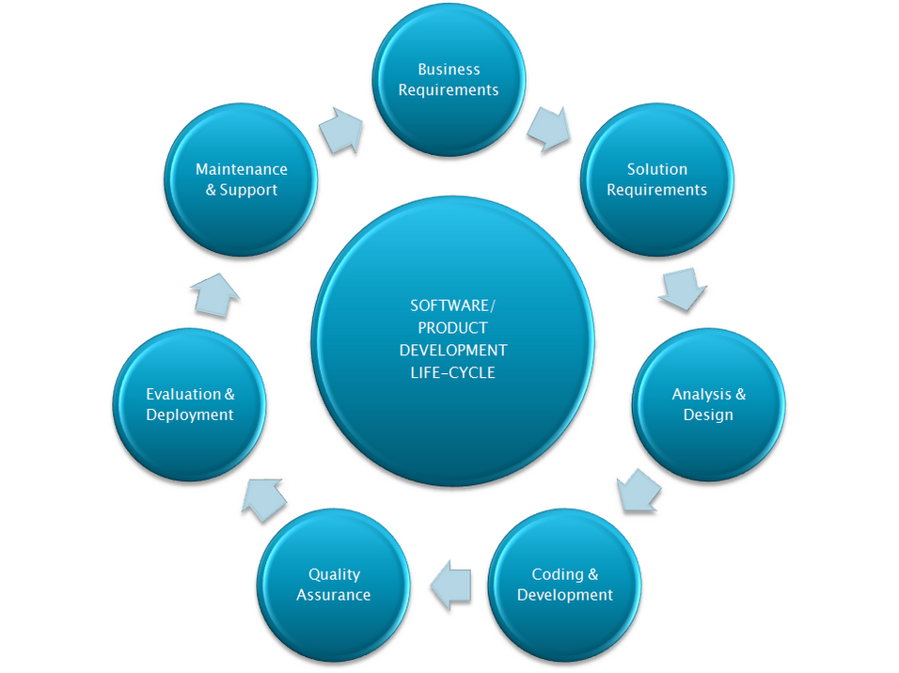

## Stage 2: Significant necessities:

Once the requirement analysis is done the next step is to clearly define and document the product requirements and get them approved from the customer or the market analysts. This is done through .SRS. . Software Requirement Specification document which consists of all the product requirements to be designed and developed during the project life cycle.

## Stage 3: Scheming the product design:

SRS is the reference for product architects to come out with the best architecture for the product to be developed. Based on the requirements specified in the SRS, usually more than one design approach for the product architecture is proposed and documented in a DDS - Design Document Specification.

This DDS is reviewed by all the important stakeholders and based on various parameters as risk assessment, product robustness, design modularity, budget and time constraints, the best design approach is selected for the product.

## Stage 4: Structure or Mounting the Product:

## In this stage of SDLC the actual development starts and the product are built. The programming code is generated as per DDS during this stage. If the design is performed in a detailed and organized manner, code generation can be accomplished without much hassle.

Developers have to follow the coding guidelines defined by their organization and programming tools like compilers, interpreters, debuggers etc.are used to generate the code. Different high level programming languages such as C, C++, Pascal, Java, and PHP are used for coding.

## Stage 5: Testing the Product:

This stage is usually a subset of all the stages as in the modern SDLC models, the testing activities are mostly involved in all the stages of SDLC. However, this stage refers to the testing only stage of the product, where product defects are reported, tracked, fixed and retested, until the product reaches the quality standards defined in the SRS.

## Stage 6: Consumption in the Market and Safeguarding:

Once the product is tested and ready to be deployed it is released formally in the appropriate market. Sometime product deployment happens in stages as per the organizations. The product may first be released in a limited segment and tested in the real business environment (UAT- User acceptance testing).

The product may be released as it is or with suggested enhancements in the targeting market segment. After the product is released in the market, its maintenance is done for the existing customer base.

**2.4 HARDWARE AND SOFTWARE REQUIREMENTS**

|  |  |  |  |
| --- | --- | --- | --- |
| Developing Kit | | | |
|  | Processor | RAM | Disk Space |
| Pycharm  Anaconda | Computer with a 2.6GHz processor or higher  Computer with a 2.6GHz processor or higher | 4GB  4GB | Minimum 20 GB  Minimum 20 GB |
| Database | | | |
| MySQL | Intel Pentium processor at 2.6GHz or faster | Minimum 512 MB Physical Memory; 1 GB Recommended | Minimum 20 GB |
| WampServer | Intel Pentium processor at 2.6GHz or faster | Minimum 512 MB Physical Memory; 1 GB Recommended | Minimum 20 GB |

**Software Requirements:**

* **Front end :** Core Python, CSS, JS
* **Web application :** Django, Flask
* **Back end :** MySQL

**OVERVIEW OF SOFTWARE ENGINEERING:**

**Software**is more than just a program code. A program is an executable code, which serves some computational purpose. Software is considered to be collection of executable programming code, associated libraries and documentations. Software, when made for a specific requirement is called software product**.** Engineering on the other hand, is all about developing products, using well-defined, scientific principles and methods.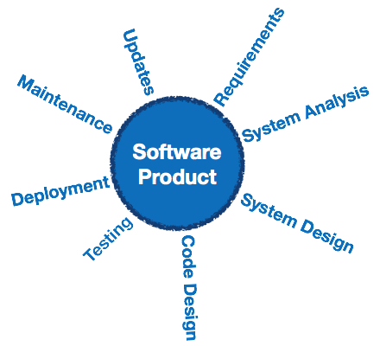

**Software engineering** is an engineering branch associated with development of software product using well-defined scientific principles, methods and procedures. The outcome of software engineering is an efficient and reliable software product.

## Definitions

IEEE defines software engineering as:

(1) The application of a systematic, disciplined, quantifiable approach to the development, operation and maintenance of software; that is, the application of engineering to software.

(2) The study of approaches as in the above statement.

Fritz Bauer, a German computer scientist, defines software engineering as:

Software engineering is the establishment and use of sound engineering principles in order to obtain economically software that is reliable and work efficiently on real machines.

## Software Evolution

The process of developing a software product using software engineering principles and methods is referred to as software evolution. This includes the initial development of software and its maintenance and updates, till desired software product is developed, which satisfies the expected requirements.

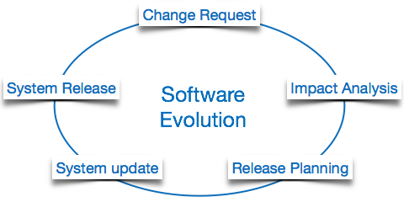

Evolution starts from the requirement gathering process. After which developers create a prototype of the intended software and show it to the users to get their feedback at the early stage of software product development. The users suggest changes, on which several consecutive updates and maintenance keep on changing too. This process changes to the original software, till the desired software is accomplished.

Even after the user has desired software in hand, the advancing technology and the changing requirements force the software product to change accordingly. Re-creating software from scratch and to go one-on-one with requirement is not feasible. The only feasible and economical solution is to update the existing software so that it matches the latest requirements.

## Software Evolution Laws

Lehman has given laws for software evolution. He divided the software into three different categories:

* **S-type (static-type) -**This is a software, which works strictly according to defined specifications and solutions. The solution and the method to achieve it, both are immediately understood before coding. The s-type software is least subjected to changes hence this is the simplest of all. For example, calculator program for mathematical computation.
* **P-type (practical-type) -**This is a software with a collection of procedures.This is defined by exactly what procedures can do. In this software, the specifications can be described but the solution is not obvious instantly. For example, gaming software.
* **E-type (embedded-type) -**This software works closely as the requirement of real-world environment. This software has a high degree of evolution as there are various changes in laws, taxes etc. in the real world situations. For example, Online trading software.

## E-Type software evolution

Lehman has given eight laws for E-Type software evolution -

* **Continuing change -**An E-type software system must continue to adapt to the real world changes, else it becomes progressively less useful.
* **Increasing complexity -**As an E-type software system evolves, its complexity tends to increase unless work is done to maintain or reduce it.
* **Conservation of familiarity -**The familiarity with the software or the knowledge about how it was developed, why was it developed in that particular manner etc. must be retained at any cost, to implement the changes in the system.
* **Continuing growth-**In order for an E-type system intended to resolve some business problem, its size of implementing the changes grows according to the lifestyle changes of the business.
* **Reducing quality -**An E-type software system declines in quality unless rigorously maintained and adapted to a changing operational environment.
* **Feedback systems-**The E-type software systems constitute multi-loop, multi-level feedback systems and must be treated as such to be successfully modified or improved.
* **Self-regulation -**E-type system evolution processes are self-regulating with the distribution of product and process measures close to normal.
* **Organizational stability -**The average effective global activity rate in an evolving E-type system is invariant over the lifetime of the product.

## Software Paradigms

Software paradigms refer to the methods and steps, which are taken while designing the software. There are many methods proposed and are in work today, but we need to see where in the software engineering these paradigms stand. These can be combined into various categories, though each of them is contained in one another:

Programming paradigm is a subset of Software design paradigm which is further a subset of Software development paradigm.

### Software Development Paradigm

This Paradigm is known as software engineering paradigms where all the engineering concepts pertaining to the development of software are applied. It includes various researches and requirement gathering which helps the software product to build. It consists of –

* Requirement gathering
* Software design
* Programming

### Software Design Paradigm

This paradigm is a part of Software Development and includes –

* Design
* Maintenance
* Programming

### Programming Paradigm

This paradigm is related closely to programming aspect of software development. This includes

* Coding
* Testing
* Integration

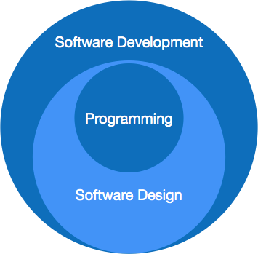

## Need of Software Engineering

The need of software engineering arises because of higher rate of change in user requirements and environment on which the software is working.

* **Large software -**It is easier to build a wall than to a house or building, likewise, as the size of software become large engineering has to step to give it a scientific process.
* **Scalability-**If the software process were not based on scientific and engineering concepts, it would be easier to re-create new software than to scale an existing one.
* **Cost-**As hardware industry has shown its skills and huge manufacturing has lower down the price of computer and electronic hardware. But the cost of software remains high if proper process is not adapted.
* **Dynamic Nature-**The always growing and adapting nature of software hugely depends upon the environment in which user works. If the nature of software is always changing, new enhancements need to be done in the existing one. This is where software engineering plays a good role.
* **Quality Management-**Better process of software development provides better and quality software product.

## Characteristics of good software

A software product can be judged by what it offers and how well it can be used. This software must satisfy on the following grounds:

* Operational
* Transitional
* Maintenance

Well-engineered and crafted software is expected to have the following characteristics:

### Operational

This tells us how well software works in operations. It can be measured on:

* Budget
* Usability
* Efficiency
* Correctness
* Functionality
* Dependability
* Security
* Safety

### Transitional

This aspect is important when the software is moved from one platform to another:

* Portability
* Interoperability
* Reusability
* Adaptability

### Maintenance

This aspect briefs about how well a software has the capabilities to maintain itself in the ever-changing environment:

* Modularity
* Maintainability
* Flexibility
* Scalability

In short, Software engineering is a branch of computer science, which uses well-defined engineering concepts required to produce efficient, durable, scalable, in-budget and on-time software products.

**SOFTWARE DEVELOPMENT LIFE CYCLE**

The Software Development Life Cycle is a process that ensures good software is built.  Each phase in the life cycle has its own process and deliverables that feed into the next phase.  There are typically 5 phases starting with the analysis and requirements gathering and ending with the implementation.  Let’s look in greater detail at each phase:

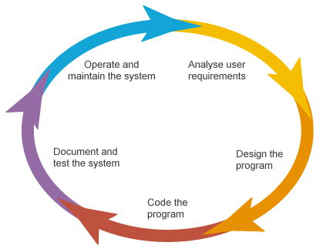

**Stage 1: Scheduling and Requisite Analysis**

During the discovery phase our team conducts a detailed requirement analysis and creates a work-breakdown structure.

**Stage 2: Scheming the product design**

We identify the design and architecture of the project. SRS is the reference for product architects to come out with the best architecture for the product to be developed.

## Stage 3: Structure or Mounting the Product

## In this stage of SDLC the actual development starts and the product is built. Different high level programming languages such as C, C++, Pascal, Java, C# and PHP are used for coding.

## Stage 4: Testing the Product

Testing is the last phase of the Software Development Life Cycle before the software is delivered to customers. During testing, experienced testers start to test the system against the requirements.

**Stage 5: Consumption in the Market and Safeguarding**

Once the product has been fully tested and no high priority issuesremain in the software, it is time to deploy to production where customers can use the system.

**2.5 INPUT AND OUTPUT**

The major inputs and outputs and major functions of the system are follows:

**Input:**

* The employee must create the account for login. All the employee details have been stored the data in our database.
* The employee gets their corresponding machines with prior training by the data trainer.
* The production team updates the error to admin to resolve the issue on production side.
* Customer purchasing the product approach the industry and provide the requirements.

**Output:**

* The production team which is monitoring the machine performance will note the error raised by the machines in the graphical view.
* Reallocating the machine has the same functionality of the faulty machine results in speedy recovery of production efficiency.

**2.5 INPUT DESIGN**

* Input design is a part of overall system design. The main objective during the input design as given below.
* Input States: User can maintain a database in MySQL server or sql server for his/her business requirement.
* Input Media:

At this stage choice has to be made about the input media. To conclude about the input media consideration has to be given to:

* In this section user can give the input for storage location and get the output from admin side.

**2.6 LIMITATIONS**

• **Lack of accurate data** – recommendation provide easy and fast results but the result are

More approximate

**. Lack of analytic capabilities-** data got from analytics results in less efficiency.

. **Uncertain-** output from recommendation system not given certain results for the user

. **Cold-start problem-** the difficulty of making recommendation when the users or the data’s are new.

. **Scalability-** recommendation system is too rigid with their algorithm

**2.7 PROBLEMS IN EXISTING SYSTEM:**

Nowadays, practically every information-intensive website has a recommender system. When a consumer is researching the target product on E-commerce companies, for instance, a list of likely favored products is shown to them. Additionally, a recommender system used in the system proposes some relevant videos to users after learning the previously generated user behaviors they are watching a video clip on Social Platform. In a sense, recommender algorithms have fundamentally altered how we find information. According to recommender systems not only make it simpler and easier for consumers to acquire information, but they also provide significant possibilities for economic growth. In prior instances, the recommendation system was carried out using the Factorization Method framework, an extension of the linear model that deals with high-dimensional spare datasets that impair the process' accuracy. In the domain of recommender systems, a major challenge is how to evaluate recommender systems comprehensively so as to find the algorithms that best suit a certain domain.

**2.8 PROPOSED SYSTEM**

Recommender systems assist consumers in discovering information, products and services that are relevant to their needs. Recommender systems are now widely deployed in many settings and many of us routinely consume recommendations from all social entertainment applications, In our project, we used recommended system to identify the data sparsity problem to complete the client project within the given time and provided a recommended solution using a regression algorithm which is gradient boosting algorithm which is often provides more accuracy and flexible while comparing to the previous method mentioned, getting a relevant data from the project team and analyze and provide a solution lead to complete a project within a time and report will be used to avoid the mistakes in the future. It can be used in various fields and for various purposes.

**Advantage of Proposed System:**

### Lower Work and Overhead- predict solutions to make it easier to complete work

* **Customer Satisfaction**-faster work can make the customer more satisfied and tends to more order
* **Provide useful Reports- output results after recommendation makes to avoid mistakes in future**
* **Time efficient-** the provided result helps solve the problem quick and efficient helps in less time consuming and provide more efficient time
* **Deliver relevant content-** the data is collected in real time so the reactiveness is probably high

.

**CHAPTER-3**

**FEASIBILITY REPORT**

**FEASIBILITY STUDY**

The feasibility of the project is analyzed in this phase and business proposal is put forth with a very general plan for the project and some cost estimates. During system analysis the feasibility study of the proposed system is to be carried out. This is to ensure that the proposed system is not a burden to the company. For feasibility analysis, some understanding of the major requirements for the system is essential.

**Three key considerations involved in the feasibility analysis are,**

* **ECONOMICAL FEASIBILITY**
* **TECHNICAL FEASIBILITY**
* **SOCIAL FEASIBILITY**

**ECONOMICAL FEASIBILITY**

This study is carried out to check the economic impact that the system will have on the organization. The amount of fund that the company can pour into the research and development of the system is limited. The expenditures must be justified. Thus the developed system as well within the budget and this was achieved because most of the technologies used are freely available. Only the customized products had to be purchased.

### TECHNICAL FEASIBILITY

This study is carried out to check the technical feasibility, that is, the technical requirements of the system. Any system developed must not have a high demand on the available technical resources. This will lead to high demands on the available technical resources. This will lead to high demands being placed on the client. The developed system must have a modest requirement, as only minimal or null changes are required for implementing this system.

**SOCIAL FEASIBILITY**

The aspect of study is to check the level of acceptance of the system by the user. This includes the process of training the user to use the system efficiently. The user must not feel threatened by the system, instead must accept it as a necessity. The level of acceptance by the users solely depends on the methods that are employed to educate the user about the system and to make him familiar with it. His level of confidence must be raised so that he is also able to make some constructive criticism, which is welcomed, as he is the final user of the system.

**CHAPTER-4**

**SOFTWARE REQUIREMENT SPECIFICATION**

**4.1 INTRODUCTION**

The purpose of this document is to present a detailed description of the Web application system. It will explain the purpose and features of the system, the interfaces of the system, what the system will do, the constraints under which it must operate and how the system will react to external stimuli. This document is intended for both the stakeholders and the developers of the system and will be proposed to the Regional Historical Society for its approval.

**PURPOSE**

The purpose of this Software Requirement Specification (SRS) is to help the project. It is provided with some requirements which are used in the Transaction Mercator System. All parts; design, coding and testing will be prepared with helping of SRS. The purpose of this document is to detail the requirements placed on the Transaction Mercator System and serves as a contract between the customer and the developers as to what is to be expected of the stock exchange, and how the components of the system are working with each other with external systems.

This document will be checked by the group member’s supervisor and it will corrected by members if supervisor orders.

**DEVELOPERS RESPONSIBILITIES OVERVIEW:**

The developer is responsible for:

* Developing the system, which meets the SRS and solving all the requirements of the system?
* Demonstrating the system and installing the system at client's location after the acceptance testing is successful.
* Submitting the required user manual describing the system interfaces to work on it and also the documents of the system.
* Conducting any user training that might be needed for using the system.
* Maintaining the system for a period of one year after installation.
  1. **FUNCTIONAL REQUIREMENTS:**
* Following is a list of functionalities of the browsing enabled system.
* An Activity with a UI that allows you to browser settings. Provide a second Activity that allows users to access the share with permission from the administrator. Handle activity lifecycle appropriately. A precondition for any points in this part of the grade is code that compiles and runs.
* Your application should allow a user to browse the shares, buy and sell the shares with specific metadata. The assignment requires you to create a UI for browsing and a UI for integrating the two.
* The Net beans provide a number of useful layout components, views, and tools that you may want to use to create your location browser. As with the final project, you should design your application to only use the buttons on the Key board and mouse as input. Your application should use the Key board, Mouse and keywords.

**4.2 NON-FUNCTIONAL REQUIREMENTS:**

* The system should be supported Net beans. The member should use the System browser. Each member should have a separate system.
* The system should ask the username and password to open the application. It doesn’t permit to unregistered user to access the System.
* The system should have Role based System functions access. Approval Process has to be defined.
* The system should have Modular customization components so that they can be reused across the implementation.
* These are the mainly following:
* Secure access of confidential data. 24 X 7 availability
* Better component design to get better performance at peak time
* Flexible service based architecture will be highly desirable for future extension

**4.3 PERFORMANCE REQUIREMENTS**

Performance is measured in terms of the output provided by the application. Requirement specification plays an important part in the analysis of a system. Only when the requirement specifications are properly given, it is possible to design a system, which will fit into required environment. It rests largely in the part of the users of the existing system to give the required specifications because they are the people who finally use the system. This is because the requirements have to be known during the initial stages so that the system can be designed according to those requirements. It is very difficult to change the system once it has been designed and on the other hand designing a system, which does not cater to the requirements of the user, is of no use.

The requirement specification for any system can be broadly stated as given below:

* The system should be able to interface with the existing system
* The system should be accurate
* The system should be better than the existing system

The existing system is completely dependent on the user to perform all the duties.

**CHAPTER-5**

**SYSTEM DEVELOPEMENT ENVIRONMENT**

**5.1 INTRODUCTION TO PYTHON**

**About Python**:

* Python was conceived in the late 1980s by [Guido van Rossum](https://en.wikipedia.org/wiki/Guido_van_Rossum) at [Centrum Wiskunde & Informatics](https://en.wikipedia.org/wiki/Centrum_Wiskunde_%26_Informatica)  in the [Netherlands](https://en.wikipedia.org/wiki/Netherlands) as a successor to [ABC programming language](https://en.wikipedia.org/wiki/ABC_(programming_language)), which was inspired by [SETL](https://en.wikipedia.org/wiki/SETL), capable of [exception handling](https://en.wikipedia.org/wiki/Exception_handling) and interfacing with the [Amoeba](https://en.wikipedia.org/wiki/Amoeba_(operating_system)) operating system. Its implementation began in December 1989; Van Rossum shouldered sole responsibility for the project, as the lead developer, until 12 July 2018, when he announced his "permanent vacation" from his responsibilities as Python's [Benevolent Dictator for Life](https://en.wikipedia.org/wiki/Benevolent_Dictator_For_Life), a title the Python community bestowed upon him to reflect his long-term commitment as the project's chief decision-maker. He now shares his leadership as a member of a five-person steering council.  In January 2019, active Python core developers elected Brett Cannon, Nick Coughlan, Barry Warsaw, Carol Willing and Van Rossum to a five-member "Steering Council" to lead the project.  Guido van Rossum has since then withdrawn his nomination for the 2020 Steering council.
* Python 2.0 was released on 16 October 2000 with many major new features, including a [cycle-detecting](https://en.wikipedia.org/wiki/Cycle_detection) [garbage collector](https://en.wikipedia.org/wiki/Garbage_collection_(computer_science)) and support for [Unicode](https://en.wikipedia.org/wiki/Unicode).
* Python 3.0 was released on 3 December 2008. It was a major revision of the language that is not completely [backward-compatible](https://en.wikipedia.org/wiki/Backward_compatibility). Many of its major features were [backported](https://en.wikipedia.org/wiki/Backporting) to Python 2.6.xand 2.7.x version series. Releases of Python 3 include the 2to3 utility, which automates (at least partially) the translation of Python 2 code to Python 3.
* Python 2.7's [end-of-life](https://en.wikipedia.org/wiki/End-of-life_(product)) date was initially set at 2015 then postponed to 2020 out of concern that a large body of existing code could not easily be forward-ported to Python 3. No more security patches or other improvements will be released for it. With Python 2's [end-of-life](https://en.wikipedia.org/wiki/End-of-life_(product)), only Python 3.6.xand later are supported.
* Python 3.9.2 and 3.8.8 were expeditedas all versions of Python (including 2.7) had security issues, leading to possible [remote code execution](https://en.wikipedia.org/wiki/Remote_code_execution) and [web cache poisoning](https://en.wikipedia.org/wiki/Cache_poisoning).

**Key points:**

* Python works on different platforms (Windows, Mac, Linux, Raspberry Pi, etc).
* Python has a simple syntax similar to the English language.
* Python has syntax that allows developers to write programs with fewer lines than some other programming languages.
* Python runs on an interpreter system, meaning that code can be executed as soon as it is written. This means that prototyping can be very quick.
* Python can be treated in a procedural way, an object-oriented way or a functional way.

**Python Syntax compared to other programming languages**

* Python was designed for readability, and has some similarities to the English language with influence from mathematics.
* Python uses new lines to complete a command, as opposed to other programming languages which often use semicolons or parentheses.
* Python relies on indentation, using whitespace, to define scope; such as the scope of loops, functions and classes. Other programming languages often use curly-brackets for this purpose.

**Importance of python to the Internet**

Python is a general-purpose language — sometimes referred to as utilitarian — which is designed to be simple to read and write. The point that it’s not a complex language is important. The designers placed less of an emphasis on conventional syntax, which makes it easier to work with, even for non-programmers or developers.Furthermore, because it’s considered truly universal and used to meet various development needs, it’s a language that [offers a lot of options to programmers](https://www.python.org/about/success/) in general. If they begin working with Python for one job or career, they can easily jump to another, even if it’s in an unrelated industry. The language is used for system operations, web development, server and administrative tools, deployment, scientific modelling and much more.But, surprisingly, many developers don’t pick up Python as their primary language. Because it’s so easy to use and learn, they choose it as a second or third language. This may be another reason why it’s so popular among developers.Plus, it just so happens that one of the biggest tech companies in the world — Google — uses the language for a number of their applications. They even have a [developer portal devoted to Python](https://developers.google.com/edu/python/), with free classes offered including exercises, lecture videos and more.In addition, the rise in the use of the Django framework for web development and a decline in popularity of PHP has also contributed to Python’s success, but, ultimately, it’s the perfect storm — just the right amount of developer and official support, as well as demand.

**Design of python:**

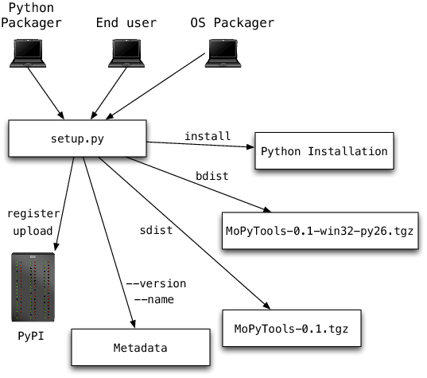

**Python Architecture**

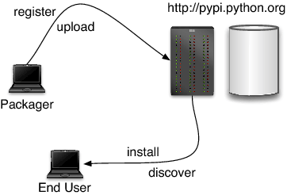

PyPy’s *Python Interpreter* is written in Python and implements the full Python language. This interpreter very closely emulates the behaviour of Python. It contains the following key components:

* a bytecode compiler responsible for producing Python code objects from the source code of a user application;
* a [bytecode evaluator](https://doc.pypy.org/en/latest/interpreter.html) responsible for interpreting Python code objects;
* a [standard object space](https://doc.pypy.org/en/latest/objspace.html#standard-object-space), responsible for creating and manipulating the Python objects seen by the application.

The *bytecode compiler* is the pre-processing phase that produces a compact bytecode format via a chain of flexible passes (tokenizer, lexer, parser, abstract syntax tree builder, bytecode generator). The *bytecode evaluator* interprets this bytecode. It does most of its work by delegating all actual manipulations of user objects to the *object space*. The latter can be thought of as the library of built-in types. It defines the implementation of the user objects, like integers and lists, as well as the operations between them, like addition or truth-value-testing.This division between bytecode evaluator and object space gives a lot of flexibility. One can plug in different [object spaces](https://doc.pypy.org/en/latest/objspace.html) to get different or enriched behaviours of the Python objects.

**Simple:**

Python was designed to be easy for the Professional programmer to learn and to use effectively. If you are an experienced C++ Programmer. Learning Python will oriented features of C++. Most of the confusing concepts from C++ are either left out of Java or implemented in a cleaner, more approachable manner. In Java there are a small number of clearly defined ways to accomplish a given task.

**Object oriented**

Python was not designed to be source-code compatible with any other language. This allowed the Python team the freedom to design with a blank state. One outcome of this was a clean, usable, pragmatic approach to objects. The object model in Python is simple and easy to extend, while simple types, such as integers, are kept as high-performance non-objects.

**Robust**

The multi-platform environment of the web places extraordinary demands on a program, because the program must execute reliably in a variety of systems. The ability to create robust programs.Was given a high priority in the design of Python. Python is strictly typed language; it checks your code at compile time and runtime.

Python virtually eliminates the problems of memory management and deal location, which is completely automatic. In a well-written Python program, all run-time errors can and should be managed by your program.

**USER AUTHORIZATION:**

One way to perform session tracking is to leverage the information that comes with User authorization. When a web server restricts access to some of its resources to only those clients that log in using a recognized username and password. After the client logs in, the username is available to a servlet through getRemoteUser ().

When use the username to track the session. Once a user has logged in, the browser remembers her user name and resends the name and password as the user views new pages on the site. A servlet can identify the user through her username and they’re by Track her session.

The biggest advantage of using user authorization to perform session tracking is that it’s easy to implement. Simply tell the protect a set of pages, and use getRemoteUser() to identify each client. Another advantage is that the technique works even when the user accesses your site form or exits her browser before coming back.

The biggest disadvantage of user authorization is that it requires each user to register for an account and then log in each time the starts visiting your site. Most users will tolerate registering and logging in as a necessary evil when they are accessing sensitive information, but it’s all overkill for simple session tracking. Another problem with user authorization is that a user cannot simultaneously maintain more than one session at the same site.

**Hidden Form Fields:**

One way to support anonymous session tracking is to use hidden from the fields. As the name implies, these are fields added to an HTML, from that are not displayed in the client’s browser, they are sent back to the server when the form that contains them is submitted.

In a sense, hidden form fields define constant variables for a form. For a servlet receiving a submitted form, there is no difference between a hidden field and a visible filed.

As more information is associated with a client’s session. It can become burdensome to pass it all using hidden form fields. In these situations, it’s possible to pass on just a unique session ID that identifies as a particular client session.

That session ID can be associated with complete information about its session that is stored on the server.

The advantage of hidden form fields is their ubiquity and support for anonymity. Hidden fields are supported in all the popular browsers, they demand on special server requirements, and they can be used with clients that haven’t registered or logged in.

The major disadvantage with this technique, however, is that works only for a sequence of dynamically generated forms, the technique breaks down immediately with static documents, emailed documents bookmarked documents and browser shutdowns.

**URL Rewriting:**

URL rewriting is another way to support anonymous session tracking, With URL rewriting every local URL the user might click on is dynamically modified. Or rewritten, to include extra, information. The extra information can be in the form of extra path information, added parameters, or some custom, server-specific.URL change. Due to the limited space available in rewriting a URL, the extra information is usually limited to a unique session.

Each rewriting technique has its own advantage and disadvantage

Using extra path information works on all servers, and it works as a target for forms that use both the Get and Post methods. It does not work well if the servlet has to use the extra path information as true path information

The advantages and disadvantages of URL. Rewriting closely match those of hidden form fields, The major difference is that URL rewriting works for all dynamically created documents, such as the Help servlet, not just forms. With the right server support, custom URL rewriting can even work for static documents.

**Persistent Cookies:**

A fourth technique to perform session tracking involves persistent cookies. A cookie is a bit of information. Sent by a web server to a browser that can later be read back form that browser. When a browser receives a cookie, it saves the cookie and there after sending the cookie back to the server each time it accesses a page on that server, subject to certain rules. Because a cookie’s value can uniquely identify a client, cookies are often used for session tracking.

Persistent cookies offer an elegant, efficient, easy way to implement session tracking. Cookies provide as automatic an introduction for each request, as we could hope for. For each request, a cookie can automatically provide a client’s session ID or perhaps a list of clients' performance. The ability to customize cookies gives them extra power and versatility.

The biggest problem with cookies is that browsers don’t always accept cookies sometimes this is because the browser doesn’t support cookies. More often it’s because the browser doesn’t support cookies. More often it’s because the user has specifically configured the browser to refuse cookies.

## Languages influenced by Python

## Python's design and philosophy have influenced many other programming languages:

* [Boo](https://en.wikipedia.org/wiki/Boo_(programming_language)) uses indentation, a similar syntax, and a similar object model.
* [Cobra](https://en.wikipedia.org/wiki/Cobra_(programming_language)) uses indentation and a similar syntax, and its *Acknowledgements* document lists Python first among languages that influenced it.
* [Coffee Script](https://en.wikipedia.org/wiki/CoffeeScript), a [programming language](https://en.wikipedia.org/wiki/Programming_language) that cross-compiles to JavaScript, has Python-inspired syntax.
* [ECMAScript](https://en.wikipedia.org/wiki/ECMAScript)/[JavaScript](https://en.wikipedia.org/wiki/JavaScript) borrowed [iterators](https://en.wikipedia.org/wiki/Iterator) and [generators](https://en.wikipedia.org/wiki/Generator_(computer_science)) from Python.
* [GD Script](https://en.wikipedia.org/wiki/GDScript), a scripting language very similar to Python, built-in to the [Godot](https://en.wikipedia.org/wiki/Godot_(game_engine)) game engine.
* [Go](https://en.wikipedia.org/wiki/Go_(programming_language)) is designed for the "speed of working in a dynamic language like Python"and shares the same syntax for slicing arrays.
* [Groovy](https://en.wikipedia.org/wiki/Groovy_(programming_language)) was motivated by the desire to bring the Python design philosophy to [Java](https://en.wikipedia.org/wiki/Java_(programming_language)).
* [Julia](https://en.wikipedia.org/wiki/Julia_(programming_language)) was designed to be "as usable for general programming as Python".
* [Nim](https://en.wikipedia.org/wiki/Nim_(programming_language)) uses indentation and similar syntax.
* [Ruby](https://en.wikipedia.org/wiki/Ruby_(programming_language))'s creator, [Yukihiro Matsumoto](https://en.wikipedia.org/wiki/Yukihiro_Matsumoto), has said: "I wanted a scripting language that was more powerful than Perl, and more object-oriented than Python. That's why I decided to design my own language.
* [Swift](https://en.wikipedia.org/wiki/Swift_(programming_language)), a programming language developed by Apple, has some Python-inspired syntax.

Python's development practices have also been emulated by other languages. For example, the practice of requiring a document describing the rationale for, and issues surrounding, a change to the language (in Python, a PEP) is also used in [Tcl](https://en.wikipedia.org/wiki/Tcl), [Erlang](https://en.wikipedia.org/wiki/Erlang_(programming_language)),,  and Swift.

**Django:**

**Django** sometimes stylized as **django** is a [Python](https://en.wikipedia.org/wiki/Python_(programming_language))-based [free and open-source](https://en.wikipedia.org/wiki/Free_and_open-source_software) [web framework](https://en.wikipedia.org/wiki/Web_framework) that follows the model-template-views (MTV) [architectural pattern](https://en.wikipedia.org/wiki/Architectural_pattern_(computer_science)). It is maintained by the [Django Software Foundation](https://en.wikipedia.org/wiki/Django_Software_Foundation) (DSF), an American independent organization established as non-profit.Django's primary goal is to ease the creation of complex, database-driven websites. The framework emphasizes [reusability](https://en.wikipedia.org/wiki/Reusability)  of components, less code, low coupling, rapid development, and the principle of [don't repeat yourself](https://en.wikipedia.org/wiki/Don%27t_repeat_yourself).Python is used throughout, even for settings, files, and data models. Django also provides an optional administrative [create, read, update and delete](https://en.wikipedia.org/wiki/Create,_read,_update_and_delete) interface that is generated dynamically through [introspection](https://en.wikipedia.org/wiki/Type_introspection) and configured via admin models. Despite having its own nomenclature, such as naming the callable objects generating the [HTTP](https://en.wikipedia.org/wiki/HTTP) responses "views",[[9]](https://en.wikipedia.org/wiki/Django_(web_framework)#cite_note-faq-mvc-9) the core Django framework can be seen as an [MVC](https://en.wikipedia.org/wiki/Model-view-controller) architecture.[[10]](https://en.wikipedia.org/wiki/Django_(web_framework)#cite_note-djangobook-mvc-10) It consists of an [object-relational mapper](https://en.wikipedia.org/wiki/Object-relational_mapping) (ORM) that mediates between [data models](https://en.wikipedia.org/wiki/Data_modeling) (defined as Python classes) and a [relational database](https://en.wikipedia.org/wiki/Relational_database) ("**M**odel"), a system for processing HTTP requests with a [web templating system](https://en.wikipedia.org/wiki/Web_template_system) ("**V**iew"), and a [regular-expression](https://en.wikipedia.org/wiki/Regular_expression)-based [URL](https://en.wikipedia.org/wiki/Uniform_Resource_Locator) dispatcher ("**C**ontroller")

**Flask:**

**Flask** is a micro [web framework](https://en.wikipedia.org/wiki/Web_framework) written in [Python](https://en.wikipedia.org/wiki/Python_(programming_language)). It is classified as a [microframework](https://en.wikipedia.org/wiki/Microframework) because it does not require particular tools or libraries.It has no database abstraction layer, form validation, or any other components where pre-existing third-party libraries provide common functions. However, Flask supports extensions that can add application features as if they were implemented in Flask itself. Extensions exist for object-relational mappers, form validation, upload handling, various open authentication technologies and several common framework related tools.

The microframework Flask is based on the Pocoo projects, Werkzeug and Jinja2.

**Werkzeug**

Werkzeug is a utility library for the [Python programming language](https://en.wikipedia.org/wiki/Python_(programming_language)), in other words a toolkit for [Web Server Gateway Interface](https://en.wikipedia.org/wiki/Web_Server_Gateway_Interface) (WSGI) applications, and is licensed under a [BSD License](https://en.wikipedia.org/wiki/BSD_licenses). Werkzeug can realize software objects for request, response, and utility functions. It can be used to build a custom [software framework](https://en.wikipedia.org/wiki/Software_framework) on top of it and supports Python 2.7 and 3.5 and later.

**Jinja**

Jinja, also by Ronacher, is a [template engine](https://en.wikipedia.org/wiki/Template_engine_(web)) for the Python programming language and is licensed under a BSD License. Similar to the [Django web framework](https://en.wikipedia.org/wiki/Django_(web_framework)), it handles templates in a [sandbox](https://en.wikipedia.org/wiki/Sandbox_(computer_security)).

**5.3 HTML, JAVASCRIPT**

Hypertext Markup Language(HTML), the languages of the World Wide Web (WWW), allows users to produce web pages that included text, graphics and pointer to other web pages (Hyperlinks).

HTML is not a programming language, but it is an application of ISO Standard 8879, SGML (Standard Generalized Markup Language), but Specialized to hypertext and adapted to the Web. The idea behind Hypertext one point to another point. We can navigate through the information based on out interest and preference. A markup language is simply a series of items enclosed within the elements should be displayed.Hyperlinks are underlined or emphasized works that load to other documents or some portions of the same document.

HTML can be used to display any type of document on the host computer, which can be geographically at a different location. It is a versatile language and can be used on any platform or desktop

HTML provides tags (special codes) to make the document look attractive.

HTML provides are not case-sensitive. Using graphics, fonts, different sizes, color, etc., can enhance the presentation of the document. Anything that is not a tag is part of the document itself.

**Basic Html Tags**:

<!-- --> Specific Comments.

<A>………</A> Creates Hypertext links.

<B>………</B> Creates hypertext links.

<Big>……..</Big> Formats text in large-font

<Body>……. </Body> contains all tags and text in the Html-document

<Center>……</Center> Creates Text

<DD>………..</DD> Definition of a term.

<TABLE>…… </TABLE> creates a table

<Td>………..</Td> indicates table data in a table.

<Tr>………..</Tr> designates a table row

<Th>………. </Th> creates a heading in a table.

##### **ADVANTAGE**

* + A HTML document is small and hence easy to send over the net. It is small because it does not include formatted information.
  + HTML is platform independent
  + HTML tags are not case-sensitive.

**5.4 JAVA SCRIPT**

JavaScript is a compact, object-based scripting language for developing client and server internet applications. Netscape Navigator 2.0 interprets JavaScript statements embedded directly in an HTML page. And Livewire enables you to create server-based applications similar to common gateway interface (CGI) programs.

In a client application for Navigator, JavaScript statements embedded in an HTML Page can recognize and respond to user events such as mouse clicks form input, and page navigation.

For example, you can write a JavaScript function to verify that users enter valid information into a form requesting a telephone number or zip code. Without any network transmission, an Html page with embedded Java Script can interpret the entered text and alert the user with a message dialog if the input is invalid or you can use JavaScript to perform an action (such as play an audio file, execute an applet, or communicate with a plug-in) in response to the user opening or exiting a page.

**CHAPTER-6**

**6.1 INTRODUCTION**

Recommendation systems help businesses generate more profit and efficiency. Most e-commerce and entertainment service businesses uses recommendation systems to increase their productivity and generate more profit and efficiency. Companies, libraries, and restaurants are increasingly utilizing recommendation systems to increase profit revenue and organizational efficiency. The recommendation system is based on recommended techniques. The recommended technique, also known as personalized information filtering, is used to predict whether a given user will like a particular project (predictive problem) or to identify a set of solutions for the (recommendation problem). In a software Industry However, a problem develops when a project team delays and it affects the client deadline leads to futuristic complications. In this case, the recommendation idea will be working to the issue and be able to complete the project with all intents and purposes with in the provided time by using the classifier algorithm and helps to overcome from the coldstart- problem and offer the appropriate fix. The fundamental notion or scope of the problem that originates from the organizing team can essentially be solved using the suggestion system.

**Module Description:**

Module Description

Module:

1) Client

2) Manager

3) Project Team

4) Technical Team

* **CLIENT**:

Clients are the more crucial one the business, firm or any organisation which are the revenue resources, Clients require projects for personal or corporate reasons and wish to contact the company by registering their company details include their organisation name, contacts, address and city what type of company in the application. So, after a client has registered and entered the login page. Which will redirect to the homepage, add their personal information in the client details part, and the next process is upload the project requirement section which contains what are the service is need to be done and the client denote the deadline for completion of project and client should select that domain, where they can upload their project details and project document with their requirements, after application approved by company the client will receive the request project from the company

**. MANAGER**:

In an organization, the manager plays an important role. Initially, the manager logs in and sees the number of client project requests here the manager decide to accept or reject project according to their company policy, so he/she can verify the client details along with their with proof attached if the details not match with policy the manager can deny the client, and then they move into the client project request section, where the manager look into the client request and requirement and deadline analyses the client project document and approves and sends the credential details to both the client and the project team, and the manager can also reject the project request when the project is not satisfied also manager receives the report from the project team when the project cannot complete in the given time, and the detail report will be forwarded to inspection for the further process after the analysis process is completed by inspection team data will be reverted back to project team and the payment is also handled by the manager

* **PROJECT TEAM**:

A project team handled all the client projects and had the responsibility to complete a project within the given time. After approving client project which is inspected by the manager the project detail of the client will be forwarded to the project team by the manager, a Project Team head was first registered his/her details and redirected to the login page after enter the credential detail the project initially view the client requirement and the next process is to upload the project team process which contains the project team head and crew members and active projects and number of projects completed to report the project team their uploaded document A project team head verifies the client project team request and then report the project inquiry to manager , if the project team finds the project cannot complete the project with given time the report will be forwarded to the inspection team, after the data is analysed by inspection team and the inspection team will provide the solution for the project team.

**. TECHNICAL TEAM:**

After approving the client project by the manager after the credential detail will be forwarded to the project team , then the project team will start the work to deliver the requested project by the client in the given time, once the situation arise when the project team knows the lag in the project about deliver into the right time the data will be forwarded to the inspection initially the inspection team registered with team details which include the total member and active members, team head and then team will view the data forwarded by project team and then using classifier algorithm inspection team will provide the result to the project team which helps the team will alter the work according from the inspection data and deliver the project in the right time.

.

**Database Screen Shot:**

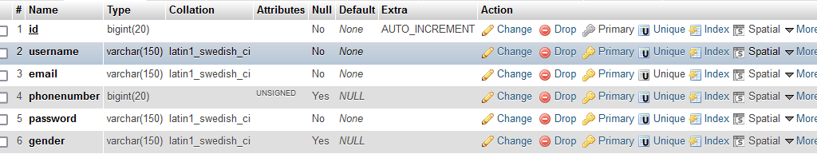

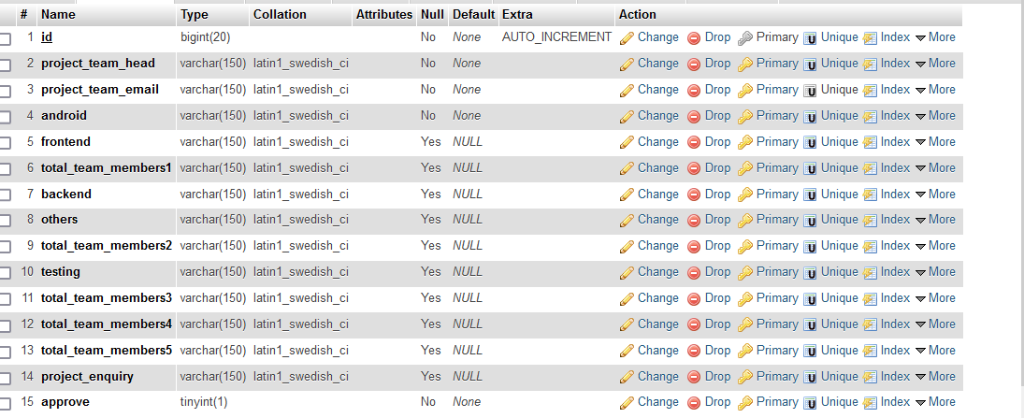

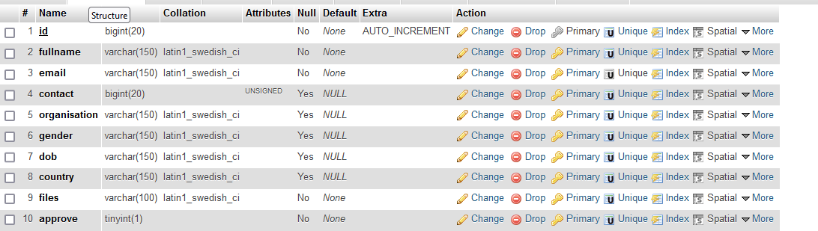

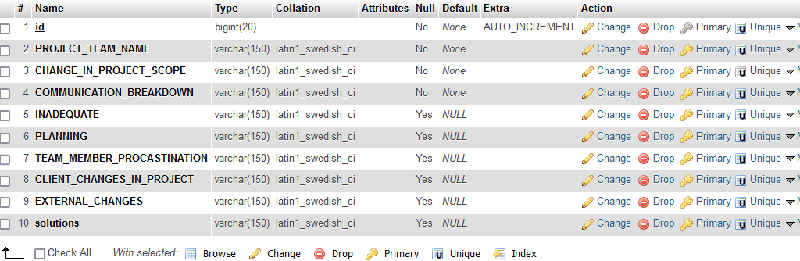

**6.3 System Architecture:**

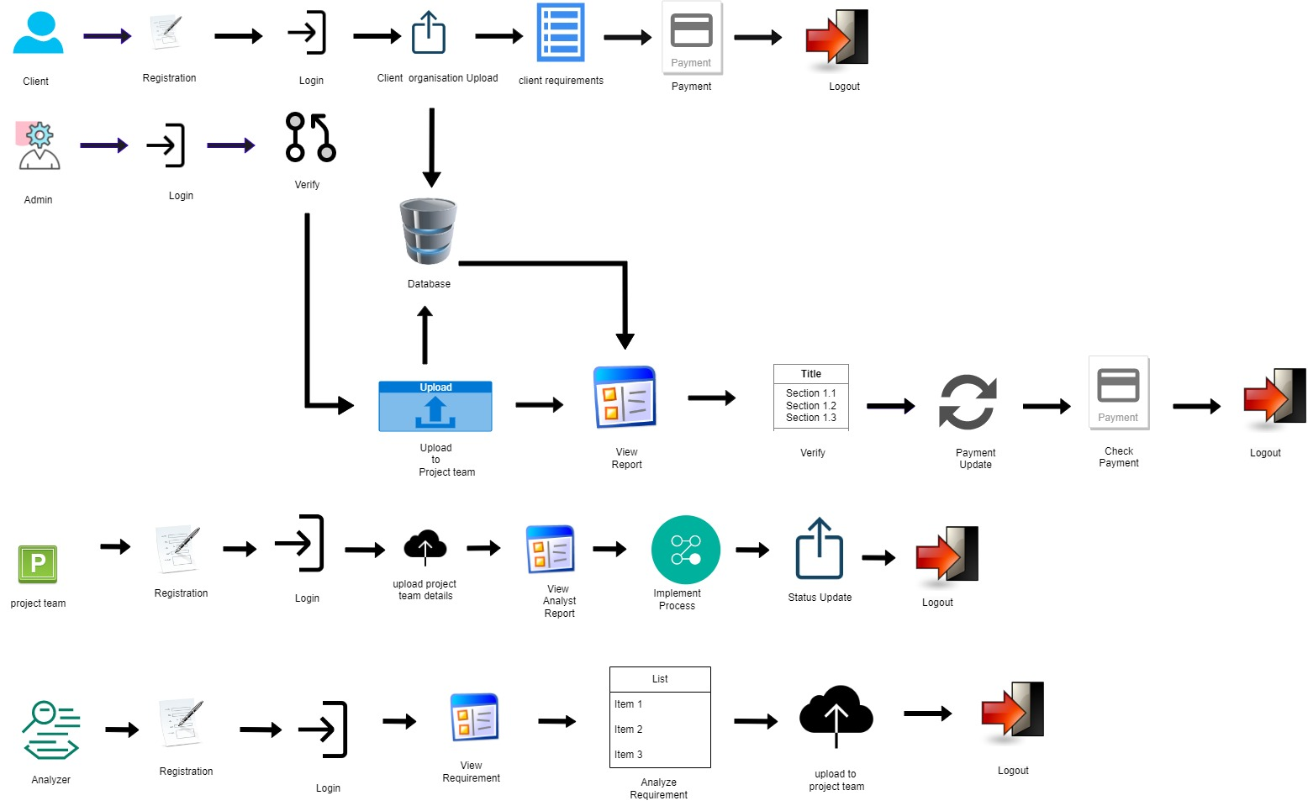

**6.4 E – R DIAGRAMS**

* + The relation upon the system is structured through a conceptual ER-Diagram, which not only specifics the existing entities, but also the standard relations through which the system exists and the cardinalities that are necessary for the system state to continue.
  + The Entity Relationship Diagram (ERD) depicts the relationship between the data objects. The ERD is the notation that is used to conduct, the date modeling activity the attributes of each data object noted, is the ERD can be described resign a data object description.
  + The set of primary components that are identified by the ERD are
  + Data object
  + Relationships
  + Attributes
  + Various types of indicators.

The primary purpose of the ERD is to represent data objects and their relationships.

**6.5 DFD SYMBOLS**

In the DFD, there are four symbols

1. A square defines a source (originating) or destination of system data
2. An arrow identifies data flow. It is the pipeline through which the information flows
3. A circle or a bubble represents a process that transforms the incoming data flow into outgoing data flows.
4. An open rectangle is a data store, data at rest or a temporary repository of data

A process that transforms the data flow

Source or Destination of data

Data flow

**CONSTRUCTING A DFD:**

Several rules of thumb are used in drawing DFD’S:

1. Process should be named and numbered for an easy reference. Each name should be representative of the process.
2. The direction of flow is from top to bottom and from left to right. Data traditionally flow from source to the destination although they may flow back to the source. One way to indicate this is to draw the long flow line back to a source. An alternative way is to repeat the source symbol as a destination. Since it is used more than once in the DFD it is marked with a short diagonal.
3. When a process is exploded into lower level details, they are numbered.
4. The names of data stores and destinations are written in capital letters. Process and dataflow names have the first letter of each work capitalized

A DFD typically shows the minimum contents of data store. Each data store should contain all the data elements that flow in and out.

Questionnaires should contain all the data elements that flow in and out. Missing interfaces redundancies and like is then accounted for often through interviews.

**SAILENT FEATURES OF DFD’S**

1. The DFD shows the flow of data, not of control loops and decision are controlled considerations do not appear on a DFD.
2. The DFD does not indicate the time factor involved in any process, whether the dataflow take place daily, weekly, monthly or yearly.
3. The sequence of events is not brought out on the DFD.

**TYPES OF DATA FLOW DIAGRAMS**

1. Current Physical
2. Current Logical
3. New Logical
4. New Physical

**CURRENT PHYSICAL**

In Current Physical DFD process label includes the name of the people or their positions or the names of computer systems that might provide some of the overall system-processing label includes an identification of the technology used to process the data. Similarly, data flows and data stores are often labelled with the names of the actual physical media on which data are stored such as file folders, computer files, business forms or computer tapes.

**CURRENT LOGICAL:**

The physical aspects in the system are removed as much as possible so that the current system is reduced to its essence to the data and the processes that transform them regardless of actual physical form.

**NEW LOGICAL:**

This is exactly like a current logical model if the user were completely happy with the user were completely happy with the functionality of the current system, but had problems with how it was implemented typically through the new logical model will differ from the current logical model while having additional functions, absolute function removal and inefficient flows recognized.

**NEW PHYSICAL:**

The new physical represents only the physical implementation of the new system.

**RULES GOVERNING THE DFD’S**

**PROCESS**

1. No process can have only outputs.
2. No process can have only inputs. If an object has only inputs than it must be a sink.
3. A process has a verb phrase label.

**DATA STORE**

1. Data cannot move directly from one data store to another data store, a process must move data.
2. Data cannot move directly from an outside source to a data store, a process, which receives, must move data from the source and place the data into the data store
3. A data store has a noun phrase label.

**SOURCE OR SINK**

The origin and /or destination of data

1. Data cannot move direly from a source to sink it must be moved from a process
2. A source and /or sink have a noun phrase land

**DATA FLOW**

1. A Data Flow has only one direction of flow between symbols. It may flow in both directions between a process and a data store to show a read before an update. The latter is usually indicated, however by two separate arrows since these happen at different type.
2. A join in DFD means that exactly the same data comes from any of two or more different processes data store or sink to a common location.
3. A data flow cannot go directly back to the same process it leads. There must be at least one other process that handles the data flow produce some other data flow returns the original data in the beginning process.
4. A Data flow to a data store means update (delete or change).
5. A data Flow from a data store means retrieve or use.

A data flow has a noun phrase label more than one data flow noun phrase can appear on a single arrow as long as all of the flows on the same arrow move together as one package.

**DATA FLOW DIAGRAMS:**

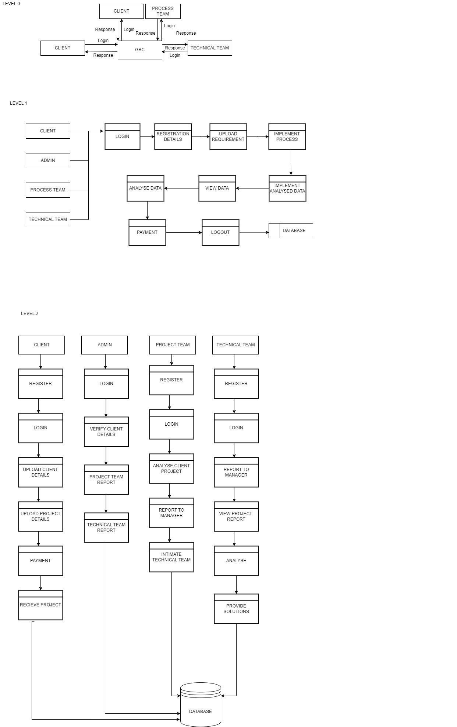

**6.6 USE CASE DIAGRAM**

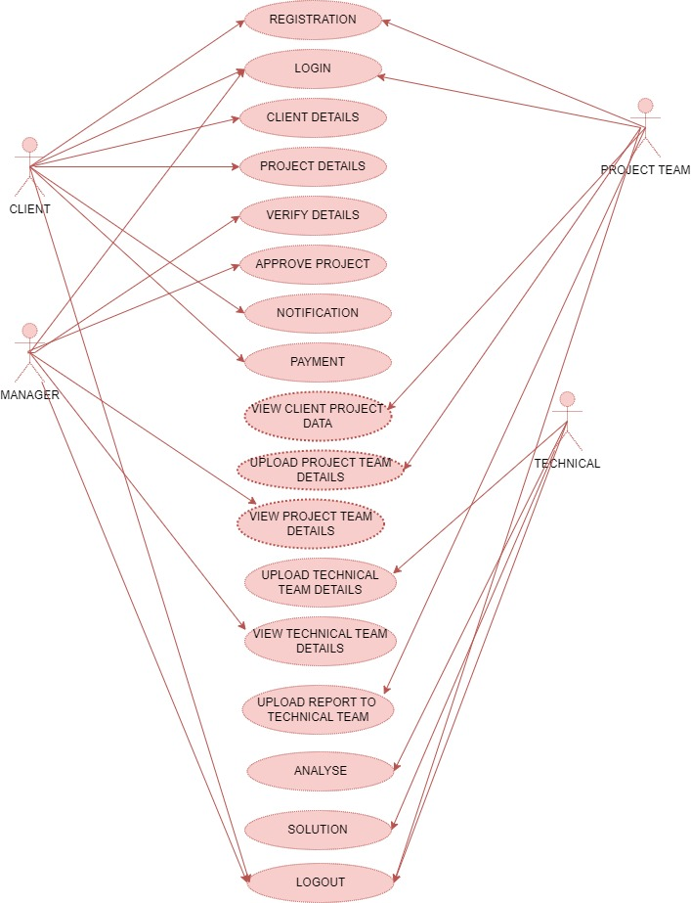

**6.7 SEQUENCE DIAGRAM**

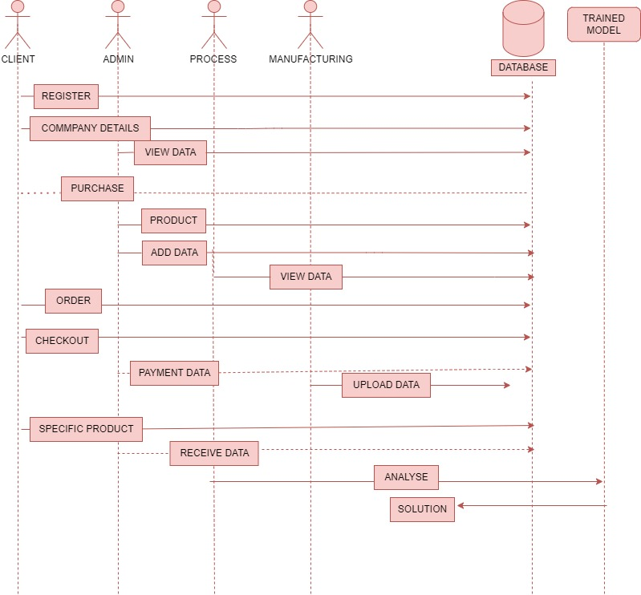

**6.8 CLASS DIAGRAM**

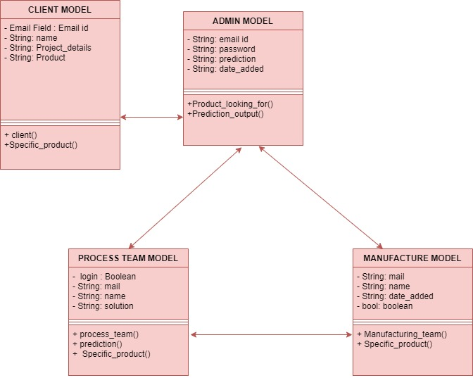

**CHAPTER-7**

**OUTPUT SCREENS**

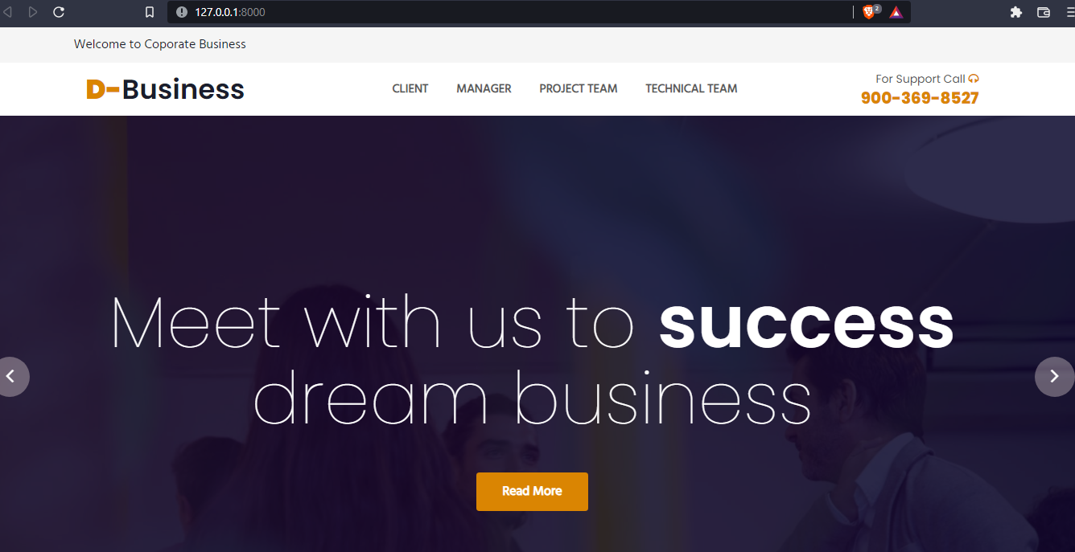

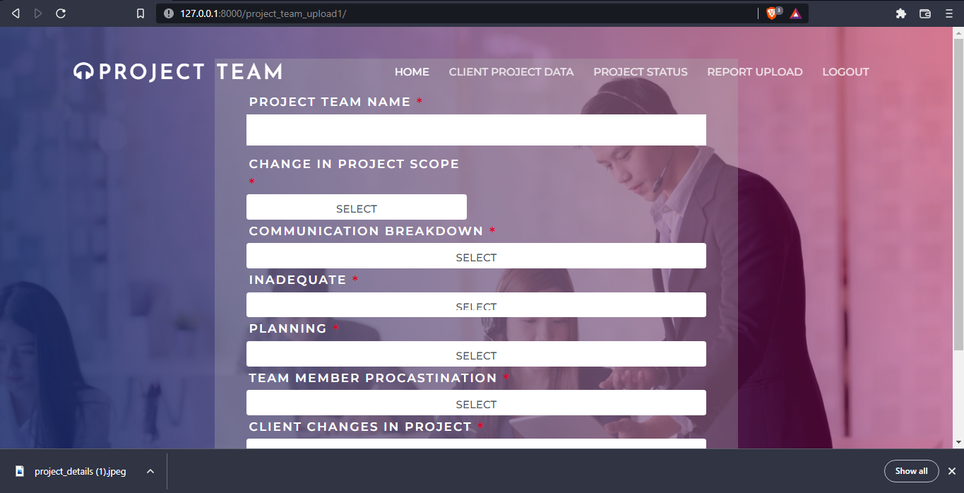

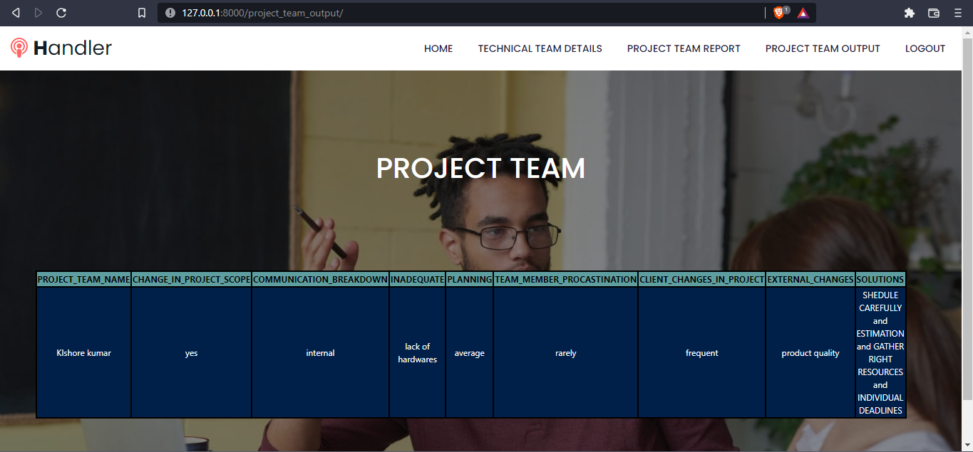

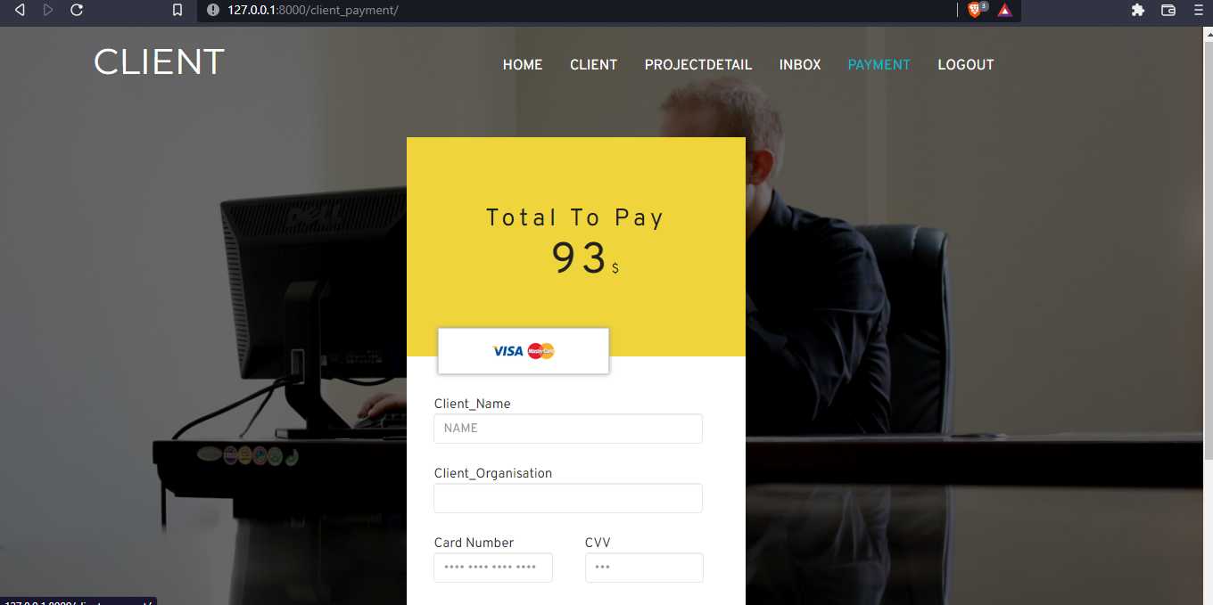

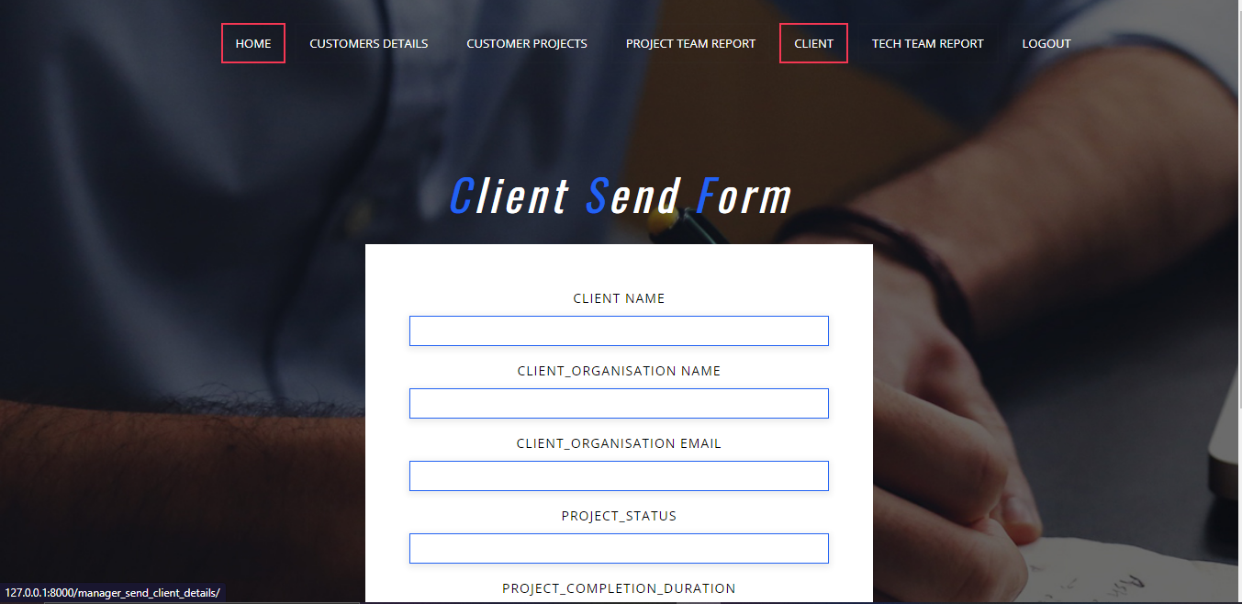

**CODINGS**

**Frontend Codings:**

<!--  
<!--  
 Author: W3layouts  
 Author URL: http://w3layouts.com  
 License: Creative Commons Attribution 3.0 Unported  
 License URL: http://creativecommons.org/licenses/by/3.0/  
-->  
<!DOCTYPE html>  
<html>  
{% load static %}  
<!-- Head -->  
<head>  
 <title>Associate a Corporate Business Category Flat Bootstrap Responsive Website Template | Home :: W3layouts</title>  
 <!-- Meta-Tags -->  
 <meta name="viewport" content="width=device-width, initial-scale=1">  
 <meta http-equiv="Content-Type" content="text/html; charset=utf-8">  
 <meta name="keywords" content="Associate a Responsive Web Template, Bootstrap Web Templates, Flat Web Templates, Android Compatible Web Template, Smartphone Compatible Web Template, Free Webdesigns for Nokia, Samsung, LG, Sony Ericsson, Motorola Web Design">  
 <script type="application/x-javascript"> addEventListener("load", function() { setTimeout(hideURLbar, 0); }, false); function hideURLbar(){ window.scrollTo(0,1); } </script>  
 <!-- //Meta-Tags -->  
 <!-- Custom-Theme-Files -->  
 <link rel="stylesheet" href="{% static 'client_home/css/bootstrap.min.css' %}" type="text/css" media="all">  
 <link rel="stylesheet" href="{% static 'client_home/css/style.css' %}" type="text/css" media="all">  
 <link rel="stylesheet" href="{% static 'client_home/css/font-awesome.min.css' %}" />  
  
 <!-- //Custom-Theme-Files -->  
 <!-- Web-Fonts -->  
 <link rel="stylesheet" href="//fonts.googleapis.com/css?family=Open+Sans:400,300,600,700,800" type="text/css">  
 <link rel="stylesheet" href="//fonts.googleapis.com/css?family=Montserrat:400,700" type="text/css">  
 <!-- //Web-Fonts -->  
 <!-- Default-JavaScript-File -->  
 <script type="text/javascript" src="{% static 'client_home/js/jquery-2.1.4.min.js' %}"></script>  
 <script type="text/javascript" src="{% static 'client_home/js/bootstrap.min.js' %}"></script>  
 <script src="{% static 'client_home/js/main.js' %}"></script>  
 <!--FlexSlider-->  
 <link rel="stylesheet" href="{% static 'client_home/css/flexslider.css' %}" type="text/css" media="screen" />  
 <script defer src="{% static 'client_home/js/jquery.flexslider.js' %}"></script>  
 <script type="text/javascript">  
 $(window).load(function(){  
 $('.flexslider').flexslider({  
 animation: "slide",  
 start: function(slider){  
 $('body').removeClass('loading');  
 }  
 });  
 });  
 </script>  
<!--End-slider-script-->  
  
</head>  
<!-- //Head -->  
<!-- Body -->  
<body>  
<script>  
{% for msg in messages %}  
  
 alert('{{ msg }}');  
{% endfor %}  
  
</script>  
 <!-- Header -->  
 <!-- banner -->  
 <div class="w3l-banner">  
  
 <div class="header">  
 <!-- Top-Bar -->  
 <div class="top-bar">  
 <div class="container">  
 <div class="header-nav">  
 <nav class="navbar navbar-default">  
 <!-- Brand and toggle get grouped for better mobile display -->  
 <div class="navbar-header">  
<!-- <button type="button" class="navbar-toggle collapsed" data-toggle="collapse" data-target="#bs-example-navbar-collapse-1">-->  
<!-- <span class="sr-only">Toggle navigation</span>-->  
<!-- <span class="icon-bar"></span>-->  
<!-- <span class="icon-bar"></span>-->  
<!-- <span class="icon-bar"></span>-->  
<!-- </button>-->  
 <h1><a class="navbar-brand" href="#">CLIENT</a></h1>  
 </div>  
 <div class="collapse navbar-collapse nav-wil" id="bs-example-navbar-collapse-1">  
 <ul class="nav navbar-nav ">  
 <li><a class="#" href="/client_index/">HOME</a></li>  
 <li><a href="/client_details_form/">CLIENT </a></li>  
 <li><a href="/client_project_details/">PROJECTDETAIL</a></li>  
 <li><a href="/client_approve/">INBOX</a></li>  
 <li><a href="/client_payment/">PAYMENT</a></li>  
 <li><a href="/logout/">LOGOUT</a></li>  
  
  
 </ul>  
 </div>  
 {% block content %}  
  
 <!-- /navbar-collapse -->  
  
 </nav>  
  
 <div class="cd-main-header">  
<!-- <a class="cd-search-trigger" href="#cd-search"> <span></span></a>-->  
 <!-- cd-header-buttons -->  
 </div>  
<!-- <div id="cd-search" class="cd-search">-->  
<!-- <form action="#" method="post">-->  
<!-- <input name="Search" type="search" placeholder="Search...">-->  
<!-- </form>-->  
<!-- </div>-->  
 </div>  
 </div>  
 </div>  
 <!-- //Top-Bar -->  
 </div>  
 <!-- //Header -->  
 <div class="container">  
 <div class="flexslider-info">  
 <section class="slider">  
 <div class="flexslider">  
 <ul class="slides">  
 <li>  
 <div class="w3l-info">  
  
 <h3>Welcome to our company</h3>  
<!-- <p>Vestibulum non sem pharetra, suscipit turpis eu, ultrices justo. Vestibulum ante ipsum primis in faucibus orci luctus et ultrices posuere cubilia.</p>-->  
<!-- <div class="agileinfo-news-button">-->  
<!-- <a href="#" class="hvr-shutter-in-horizontal" data-toggle="modal" data-target="#myModal"> Read More</a>-->  
<!-- </div>-->  
<!-- </div>-->  
<!-- </li>-->  
<!-- <li>-->  
<!-- <div class="w3l-info">-->  
<!-- <h3>Welcome to our company</h3>-->  
<!-- <p>Vestibulum non sem pharetra, suscipit turpis eu, ultrices justo. Vestibulum ante ipsum primis in faucibus orci luctus et ultrices posuere cubilia.</p>-->  
<!-- <div class="agileinfo-news-button">-->  
<!-- <a href="#" class="hvr-shutter-in-horizontal" data-toggle="modal" data-target="#myModal"> Read More</a>-->  
<!-- </div>-->  
<!-- </div>-->  
<!-- </li>-->  
<!-- <li>-->  
<!-- <div class="w3l-info">-->  
<!-- <h3>Welcome to our company</h3>-->  
  
<!-- <p>Vestibulum non sem pharetra, suscipit turpis eu, ultrices justo. Vestibulum ante ipsum primis in faucibus orci luctus et ultrices posuere cubilia.</p>-->  
<!-- <div class="agileinfo-news-button">-->  
<!-- <a href="#" class="hvr-shutter-in-horizontal" data-toggle="modal" data-target="#myModal"> Read More</a>-->  
<!-- </div>-->  
 {% endblock %}  
<!-- </div>-->  
<!-- </li>-->  
<!-- </ul>-->  
<!-- </div>-->  
<!-- </section>-->  
<!-- </div>-->  
<!-- </div>-->  
<!-- </div>-->  
<!-- &lt;!&ndash; //banner &ndash;&gt;-->  
<!-- &lt;!&ndash; banner-bottom &ndash;&gt;-->  
<!-- <div class="w3layouts-banner-bottom">-->  
<!-- <div class="container">-->  
<!-- <div class="col-md-3 agileits-bottom-top">-->  
<!-- <h3>Management<br><span>vestibulum eros sagittis. Nulla ultricies</span><br></h3>-->  
<!-- </div>-->  
<!-- <div class="col-md-3 agileits-bottom-top">-->  
<!-- <h3>your goals<br><span>vestibulum eros sagittis. Nulla ultricies</span><br></h3>-->  
<!-- </div>-->  
<!-- <div class="col-md-3 agileits-bottom-top">-->  
<!-- <h3>Ipsum primis<br><span>vestibulum eros sagittis. Nulla ultricies</span><br></h3>-->  
<!-- </div>-->  
<!-- <div class="col-md-3 agileits-bottom-top">-->  
<!-- <h3>Taxation<br><span>vestibulum eros sagittis. Nulla ultricies</span><br></h3>-->  
<!-- </div>-->  
<!-- <div class="clearfix"></div>-->  
<!-- </div>-->  
<!-- </div>-->  
<!-- &lt;!&ndash; //banner-bottom &ndash;&gt;-->  
<!-- &lt;!&ndash; welcome &ndash;&gt;-->  
<!-- <div class="wthree-welcome">-->  
<!-- <div class="container">-->  
<!-- <h2>Welcome</h2>-->  
<!-- <div class="border"> </div>-->  
<!-- -->  
<!-- <div class="col-md-6 wthree-welcome-left">-->  
<!-- <p>Nullam maximus dolor sed velit gravida, quis vestibulum eros sagittis. Nulla ultricies metus a turpis pretium volutpat. Cras consectetur tempus lectus id accumsan. Vivamus gravida justo mattis ex pretium, eu sollicitudin tortor ullamcorper. Quisque vitae diam molestie, tincidunt velit vitae, viverra nisl. Mauris ultrices commodo imperdiet. In urna odio, semper nec est non, pulvinar molestie quam. Etiam egestas varius nunc et rutrum. Curabitur tempor lacinia pharetra. Ut laoreet urna sed risus consequat laoreet. In volutpat sollicitudin volutpat. </p>-->  
<!-- <div class="agileinfo-news-button">-->  
<!-- <a href="#" class="hvr-shutter-in-horizontal" data-toggle="modal" data-target="#myModal"> Learn More</a>-->  
<!-- </div>-->  
<!-- </div>-->  
<!-- <div class="col-md-6 wthree-welcome-right">-->  
<!-- <img class="img-responsive" src="{% static 'client_home/images/1.jpg' %}" alt=" ">-->  
<!-- </div>-->  
<!-- <div class="clearfix"></div>-->  
<!-- </div>-->  
<!-- </div>-->  
<!-- &lt;!&ndash; //welcome &ndash;&gt;-->  
<!-- &lt;!&ndash; video &ndash;&gt;-->  
<!-- <div class="video-w3-agileits">-->  
<!-- <h3>Watch our Intro</h3>-->  
<!-- <a href="#" data-toggle="modal" data-target="#modalvideo"><i class="fa fa-play" aria-hidden="true"></i></a>-->  
<!-- <div class="modal fade features-modal" id="modalvideo" tabindex="-1" role="dialog" aria-hidden="true">-->  
<!-- <div class="modal-dialog modal-lg">-->  
<!-- <div class="modal-content">-->  
<!-- <div class="modal-header">-->  
<!-- <button type="button" class="close" data-dismiss="modal" aria-hidden="true">×</button>-->  
<!-- </div>-->  
<!-- <div class="modal-body">-->  
<!-- <iframe src="https://player.vimeo.com/video/63078884" webkitallowfullscreen mozallowfullscreen allowfullscreen></iframe>-->  
<!-- </div>-->  
<!-- </div>-->  
<!-- </div>-->  
<!-- </div>-->  
<!-- <p>At vero eos et accusamus et iusto odio dignissimos ducimus qui blanditiis praesentium voluptatum deleniti atque corrupti quos dolores </p>-->  
<!-- </div>-->  
<!-- &lt;!&ndash; //video &ndash;&gt;-->  
<!-- &lt;!&ndash; features &ndash;&gt;-->  
<!-- <div class="features">-->  
<!-- <div class="container">-->  
<!-- <h3>Features</h3>-->  
<!-- <div class="border"> </div>-->  
<!-- <div class="bs-example bs-example-tabs" role="tabpanel" data-example-id="togglable-tabs">-->  
<!-- <ul id="myTab" class="nav nav-tabs" role="tablist">-->  
<!-- <li role="presentation" class="active"><a href="#home" id="home-tab" role="tab" data-toggle="tab" aria-controls="home" aria-expanded="true">Feature-1</a></li>-->  
<!-- <li role="presentation" class=""><a href="#Feature1" role="tab" id="Feature1-tab" data-toggle="tab" aria-controls="Feature1" aria-expanded="false">Feature-2</a></li>-->  
<!-- <li role="presentation" class=""><a href="#Feature2" role="tab" id="Feature2-tab" data-toggle="tab" aria-controls="Feature2" aria-expanded="false">Feature-3</a></li>-->  
<!-- <li role="presentation" class=""><a href="#Feature3" role="tab" id="Feature3-tab" data-toggle="tab" aria-controls="Feature3" aria-expanded="false">Feature-4</a></li>-->  
<!-- </ul>-->  
<!-- <div id="myTabContent" class="tab-content">-->  
<!-- <div role="tabpanel" class="tab-pane fade active in" id="home" aria-labelledby="home-tab">-->  
<!-- <div class="w3agile_tabs">-->  
<!-- <div class="col-md-5 w3agile_tab_right w3agile_tab_right2">-->  
<!-- <img src="{% static 'client_home/images/2.jpg' %}" alt=" " class="img-responsive">-->  
<!-- </div>-->  
<!-- <div class="col-md-7 w3agile_tab_left">-->  
<!-- <h4>pulvinar vitae sem sit</h4>-->  
<!-- <p> Cras consectetur tempus lectus id accumsan. Vivamus gravida justo mattis ex pretium, eu sollicitudin tortor ullamcorper. Quisque vitae diam molestie, tincidunt velit vitae, viverra nisl. Mauris ultrices commodo imperdiet. In urna odio, semper nec est non, pulvinar molestie quam. Etiam egestas varius nunc et rutrum. Curabitur tempor lacinia pharetra. Ut laoreet urna sed risus consequat laoreet. In volutpat sollicitudin volutpat.eget auctor eros -->  
<!-- ultrices. Vestibulum non erat ut odio euismod accumsan. -->  
<!-- Phasellus libero tellus, pulvinar vitae sem sit amet, -->  
<!-- faucibus consectetur neque.</p>-->  
<!-- -->  
<!-- </div>-->  
<!-- <div class="clearfix"> </div>-->  
<!-- </div>-->  
<!-- </div>-->  
<!-- <div role="tabpanel" class="tab-pane fade" id="Feature1" aria-labelledby="Feature1-tab">-->  
<!-- <div class="w3agile_tabs">-->  
<!-- <div class="col-md-7 w3agile_tab_left">-->  
<!-- <h4>suscipit sapien nec </h4>-->  
<!-- <p> Cras consectetur tempus lectus id accumsan. Vivamus gravida justo mattis ex pretium, eu sollicitudin tortor ullamcorper. Quisque vitae diam molestie, tincidunt velit vitae, viverra nisl. Mauris ultrices commodo imperdiet. In urna odio, semper nec est non, pulvinar molestie quam. Etiam egestas varius nunc et rutrum. Curabitur tempor lacinia pharetra. Ut laoreet urna sed risus consequat laoreet. In volutpat sollicitudin volutpat. eget auctor eros -->  
<!-- ultrices. Vestibulum non erat ut odio euismod accumsan. -->  
<!-- Phasellus libero tellus, pulvinar vitae sem sit amet, -->  
<!-- faucibus consectetur neque.</p>-->  
<!-- </div>-->  
<!-- <div class="col-md-5 w3agile_tab_right w3agile_tab_right1">-->  
<!-- <img src="{% static 'client_home/images/3.jpg' %}" alt=" " class="img-responsive">-->  
<!-- </div>-->  
<!-- <div class="clearfix"> </div>-->  
<!-- </div>-->  
<!-- </div>-->  
<!-- <div role="tabpanel" class="tab-pane fade" id="Feature2" aria-labelledby="Feature2-tab">-->  
<!-- <div class="w3agile_tabs">-->  
<!-- <div class="col-md-5 w3agile_tab_right w3agile_tab_right2">-->  
<!-- <img src="{% static 'client_home/images/4.jpg' %}" alt=" " class="img-responsive">-->  
<!-- </div>-->  
<!-- <div class="col-md-7 w3agile_tab_left">-->  
<!-- <h4>gravida eget auctor </h4>-->  
<!-- <p> Cras consectetur tempus lectus id accumsan. Vivamus gravida justo mattis ex pretium, eu sollicitudin tortor ullamcorper. Quisque vitae diam molestie, tincidunt velit vitae, viverra nisl. Mauris ultrices commodo imperdiet. In urna odio, semper nec est non, pulvinar molestie quam. Etiam egestas varius nunc et rutrum. Curabitur tempor lacinia pharetra. Ut laoreet urna sed risus consequat laoreet. In volutpat sollicitudin volutpat. eget auctor eros -->  
<!-- ultrices. Vestibulum non erat ut odio euismod accumsan. -->  
<!-- Phasellus libero tellus, pulvinar vitae sem sit amet, -->  
<!-- faucibus consectetur neque.</p>-->  
<!-- -->  
<!-- </div>-->  
<!-- <div class="clearfix"> </div>-->  
<!-- </div>-->  
<!-- </div>-->  
<!-- <div role="tabpanel" class="tab-pane fade" id="Feature3" aria-labelledby="Feature3-tab"><div class="w3agile_tabs">-->  
<!-- <div class="col-md-7 w3agile_tab_left">-->  
<!-- <h4>faucibus consectetur </h4>-->  
<!-- <p> Cras consectetur tempus lectus id accumsan. Vivamus gravida justo mattis ex pretium, eu sollicitudin tortor ullamcorper. Quisque vitae diam molestie, tincidunt velit vitae, viverra nisl. Mauris ultrices commodo imperdiet. In urna odio, semper nec est non, pulvinar molestie quam. Etiam egestas varius nunc et rutrum. Curabitur tempor lacinia pharetra. Ut laoreet urna sed risus consequat laoreet. In volutpat sollicitudin volutpat. eget auctor eros -->  
<!-- ultrices. Vestibulum non erat ut odio euismod accumsan. -->  
<!-- Phasellus libero tellus, pulvinar vitae sem sit amet, -->  
<!-- faucibus consectetur neque.</p>-->  
<!-- -->  
<!-- </div>-->  
<!-- <div class="col-md-5 w3agile_tab_right w3agile_tab_right1">-->  
<!-- <img src="{% static 'client_home/images/5.jpg' %}" alt=" " class="img-responsive">-->  
<!-- </div>-->  
<!-- <div class="clearfix"> </div>-->  
<!-- </div>-->  
<!-- </div>-->  
<!-- </div>-->  
<!-- </div>-->  
<!-- </div>-->  
<!-- </div>-->  
<!-- &lt;!&ndash; //features&ndash;&gt;-->  
<!-- &lt;!&ndash; services-bottom &ndash;&gt;-->  
<!-- <div class="services-bottom">-->  
<!-- <div class="container">-->  
<!-- <div class="col-md-3 agileits_w3layouts_about_counter_left">-->  
<!-- <p class="counter">561</p> -->  
<!-- <i class="glyphicon glyphicon-user" aria-hidden="true"></i>-->  
<!-- -->  
<!-- <h3>Satisfied Clients</h3>-->  
<!-- </div>-->  
<!-- <div class="col-md-3 agileits_w3layouts_about_counter_left">-->  
<!-- <p class="counter">180</p> -->  
<!-- <i class="fa fa-file-text-o" aria-hidden="true"></i>-->  
<!-- -->  
<!-- <h3>Projects Complete</h3>-->  
<!-- </div>-->  
<!-- <div class="col-md-3 agileits_w3layouts_about_counter_left">-->  
<!-- <p class="counter">650</p>-->  
<!-- <i class="fa fa-calendar" aria-hidden="true"></i>-->  
<!-- -->  
<!-- <h3>days of work</h3>-->  
<!-- </div>-->  
<!-- <div class="col-md-3 agileits_w3layouts_about_counter_left">-->  
<!-- <p class="counter">1100</p>-->  
<!-- <i class="fa fa-life-ring" aria-hidden="true"></i>-->  
<!-- -->  
<!-- <h3>Support</h3>-->  
<!-- </div>-->  
<!-- <div class="clearfix"> </div>-->  
<!-- &lt;!&ndash; Stats-Number-Scroller-Animation-JavaScript &ndash;&gt;-->  
<!-- <script src="{% static 'client_home/js/waypoints.min.js' %}"></script>-->  
<!-- <script src="{% static 'client_home/js/counterup.min.js' %}"></script>-->  
<!-- <script>-->  
<!-- jQuery(document).ready(function( $ ) {-->  
<!-- $('.counter').counterUp({-->  
<!-- delay: 100,-->  
<!-- time: 1000-->  
<!-- });-->  
<!-- });-->  
<!-- </script>-->  
<!-- &lt;!&ndash; //Stats-Number-Scroller-Animation-JavaScript &ndash;&gt;-->  
  
<!-- </div>-->  
<!-- </div>-->  
<!-- &lt;!&ndash; //services-bottom &ndash;&gt;-->  
<!-- &lt;!&ndash; footer &ndash;&gt;-->  
<!-- <div class="footer-top">-->  
<!-- <div class="container">-->  
<!-- <div class="col-md-5 w3l-footer-top">-->  
<!-- <h3>NEWSLETTER</h3>-->  
<!-- <p>Quis autem vel eum iure reprehenderit qui in ea voluptate velit reprehenderit qui in ea.</p>-->  
  
<!-- <form action="#" method="post" class="newsletter">-->  
<!-- <input class="email" type="email" placeholder="Your email..." required="">-->  
<!-- <input type="submit" class="submit" value="">-->  
<!-- </form>-->  
<!-- -->  
<!-- </div>-->  
<!-- -->  
<!-- <div class="col-md-5 wthree-footer-top">-->  
<!-- <h3>About</h3>-->  
<!-- <p>Cras consectetur tempus lectus id accumsan. Vivamus gravida justo mattis ex pretium, eu sollicitudin tortor ullamcorper. Quisque vitae diam molestie, tincidunt velit vitae, viverra nisl. Mauris ultrices commodo imperdiet. </p>-->  
<!-- </div>-->  
<!-- <div class="col-md-2 w3ls-footer-top">-->  
<!-- <h3>Options</h3>-->  
<!-- <ul>-->  
<!-- <li><a href="index.html">Home</a></li>-->  
<!-- <li><a href="about.html">About</a></li>-->  
<!-- <li><a href="gallery.html">Gallery</a></li>-->  
<!-- <li><a href="icons.html">Short Codes</a></li>-->  
<!-- <li><a href="contact.html">Contact</a></li>-->  
<!-- </ul>-->  
<!-- </div>-->  
<!-- -->  
<!-- <div class="clearfix"></div>-->  
<!-- -->  
<!-- </div>-->  
<!-- </div>-->  
<!-- <div class="footer-w3layouts">-->  
<!-- <div class="container">-->  
<!-- <div class="agile-copy">-->  
<!-- <p>© 2016 Associate. All rights reserved | Design by <a href="http://w3layouts.com/">W3layouts</a></p>-->  
<!-- </div>-->  
<!-- <div class="agileits-social">-->  
<!-- <ul>-->  
<!-- <li><a href="#"><i class="fa fa-facebook"></i></a></li>-->  
<!-- <li><a href="#"><i class="fa fa-twitter"></i></a></li>-->  
<!-- <li><a href="#"><i class="fa fa-rss"></i></a></li>-->  
<!-- <li><a href="#"><i class="fa fa-vk"></i></a></li>-->  
<!-- </ul>-->  
<!-- </div>-->  
<!-- <div class="clearfix"></div>-->  
<!-- </div>-->  
<!-- </div>-->  
<!-- &lt;!&ndash; //footer &ndash;&gt;-->  
<!-- <div class="modal about-modal fade" id="myModal" tabindex="-1" role="dialog">-->  
<!-- <div class="modal-dialog" role="document">-->  
<!-- <div class="modal-content">-->  
<!-- <div class="modal-header"> -->  
<!-- <button type="button" class="close" data-dismiss="modal" aria-label="Close"><span aria-hidden="true">&times;</span></button> -->  
<!-- <h4 class="modal-title">Associate</h4>-->  
<!-- </div> -->  
<!-- <div class="modal-body">-->  
<!-- <div class="agileits-w3layouts-info">-->  
<!-- <img src="{% static 'client_home/images/g1.jpg' %}" class="img-responsive" alt="" />-->  
<!-- <p>Duis venenatis, turpis eu bibendum porttitor, sapien quam ultricies tellus, ac rhoncus risus odio eget nunc. Pellentesque ac fermentum diam. Integer eu facilisis nunc, a iaculis felis. Pellentesque pellentesque tempor enim, in dapibus turpis porttitor quis. Suspendisse ultrices hendrerit massa. Nam id metus id tellus ultrices ullamcorper. Cras tempor massa luctus, varius lacus sit amet, blandit lorem. Duis auctor in tortor sed tristique. Proin sed finibus sem.</p>-->  
<!-- </div>-->  
<!-- </div>-->  
<!-- </div>-->  
<!-- </div>-->  
  
<!-- </div>-->  
<!-- &lt;!&ndash; //modal &ndash;&gt; -->  
  
</body>  
<!-- //Body -->  
</html>

<!--  
 Author: W3layouts  
 Author URL: http://w3layouts.com  
 License: Creative Commons Attribution 3.0 Unported  
 License URL: http://creativecommons.org/licenses/by/3.0/  
-->  
  
<!DOCTYPE html>  
{% load static %}  
{% csrf_token %}  
<html>  
  
<!-- Head -->  
<head>  
  
<title>WELCOME</title>  
  
  
<!-- Meta-Tags -->  
<meta name="viewport" content="width=device-width, initial-scale=1">  
<meta http-equiv="Content-Type" content="text/html; charset=utf-8">  
<meta name="keywords" content="Existing Login Form Widget Responsive, Login Form Web Template, Flat Pricing Tables, Flat Drop-Downs, Sign-Up Web Templates, Flat Web Templates, Login Sign-up Responsive Web Template, Smartphone Compatible Web Template, Free Web Designs for Nokia, Samsung, LG, Sony Ericsson, Motorola Web Design">  
<script type="application/x-javascript"> addEventListener("load", function() { setTimeout(hideURLbar, 0); }, false); function hideURLbar(){ window.scrollTo(0,1); } </script>  
<!-- //Meta-Tags -->  
  
<link href="{% static 'client_login_register/css/popuo-box.css' %}" rel="stylesheet" type="text/css" media="all" />  
  
<!-- Style --> <link rel="stylesheet" href="{% static 'client_login_register/css/style.css' %}" type="text/css" media="all">  
  
<!-- Fonts -->  
<link href="//fonts.googleapis.com/css?family=Quicksand:300,400,500,700" rel="stylesheet">  
<!-- //Fonts -->  
  
</head>  
<!-- //Head -->  
  
<!-- Body -->  
<body>  
  
<script>  
{% for msg in messages %}  
  
 alert('{{ msg }}');  
{% endfor %}  
  
</script>  
  
 <h1>WELCOME</h1>  
  
 <div class="w3layoutscontaineragileits">  
 <h2>Login here</h2>  
 <form action="/client_login/" method="post">  
 {% csrf_token %}  
 <input type="text" name="email" placeholder="EMAIL" pattern="[a-z0-9._%+-]+@[a-z0-9.-]+\.[a-z]{2,}$" autocomplete="off" >  
 <input type="password" name="password" placeholder="PASSWORD" pattern="(?=.*\d)(?=.*[a-z])(?=.*[A-Z]).{8,}" autocomplete="off">  
 <div class="aitssendbuttonw3ls">  
 <input type="submit" value="LOGIN">  
 <p> To register new account <span>→</span> <a class="w3_play_icon1" href="#small-dialog1"> Click Here</a></p>  
 <div class="clear"></div>  
 </div>  
 </form>  
 </div>  
  
 <!-- for register popup -->  
 <div id="small-dialog1" class="mfp-hide">  
 <div class="contact-form1">  
 <div class="contact-w3-agileits">  
 <h3>Register Form</h3>  
 <form action="/client_reg/" method="post">  
 {%csrf_token %}  
 <div class="form-sub-w3ls">  
 <input placeholder="USERNAME" name="username" type="text" autocomplete="off">  
 <div class="icon-agile">  
 <i class="fa fa-user" aria-hidden="true"></i>  
 </div>  
 </div>  
 <div class="form-sub-w3ls">  
 <input placeholder="EMAIL" name="email" class="mail" type="email" pattern="[a-z0-9._%+-]+@[a-z0-9.-]+\.[a-z]{2,}$" autocomplete="off">  
 <div class="icon-agile">  
 <i class="fa fa-envelope-o" aria-hidden="true"></i>  
 </div>  
 </div>  
 <div class="form-sub-w3ls">  
 <input placeholder="PASSWORD" name="password" type="password" pattern="(?=.*\d)(?=.*[a-z])(?=.*[A-Z]).{8,}" autocomplete="off">  
 <div class="icon-agile">  
 <i class="fa fa-unlock-alt" aria-hidden="true"></i>  
 </div>  
 </div>  
 <div class="form-sub-w3ls">  
 <input placeholder="PHONENUMBER" name="phonenumber" type="text" pattern="[6789][0-9]{9,}" autocomplete="off" maxlength="10"/>  
  
 </div>  
  
 <div class="form-sub-w3ls">  
 <input placeholder="GENDER" name="gender" type="text" autocomplete="off">  
  
  
  
 </div>  
  
 <div class="form-sub-w3ls">  
 <input placeholder="ADDRESS" name="address" type="text" autocomplete="off">  
  
 </div>  
  
  
  
 <div class="login-check">  
 <label class="checkbox"><input type="checkbox" name="checkbox" checked="">I Accept Terms & Conditions</label>  
 </div>  
 <div class="submit-w3l">  
 <input type="submit" value="Register">  
 </div>  
 </form>  
 </div>  
 </div>  
 </div>  
 <!-- //for register popup -->  
  
 <div class="w3footeragile">  
 <p> &copy; 2017 Existing Login Form. All Rights Reserved | Design by <a href="http://w3layouts.com" target="_blank">W3layouts</a></p>  
 </div>  
  
  
 <script type="text/javascript" src="{% static 'client_login_register/js/jquery-2.1.4.min.js' %}"></script>  
  
 <!-- pop-up-box-js-file -->  
 <script src="{% static 'client_login_register/js/jquery.magnific-popup.js' %}" type="text/javascript"></script>  
 <!--//pop-up-box-js-file -->  
 <script>  
 $(document).ready(function() {  
 $('.w3_play_icon,.w3_play_icon1,.w3_play_icon2').magnificPopup({  
 type: 'inline',  
 fixedContentPos: false,  
 fixedBgPos: true,  
 overflowY: 'auto',  
 closeBtnInside: true,  
 preloader: false,  
 midClick: true,  
 removalDelay: 300,  
 mainClass: 'my-mfp-zoom-in'  
 });  
  
 });  
 </script>  
  
</body>  
<!-- //Body -->  
  
</html>

<!--  
author: W3layouts  
author URL: http://w3layouts.com  
License: Creative Commons Attribution 3.0 Unported  
License URL: http://creativecommons.org/licenses/by/3.0/  
-->  
<!DOCTYPE html>  
<html lang="en">  
{% extends 'manager/manager_index.html' %}  
{% load static %}  
{% block content %}  
<head>  
<title>Controller a Corporate Category Flat Bootstrap Responsive Website Template | Home :: w3layouts</title>  
<!-- for-mobile-apps -->  
<meta name="viewport" content="width=device-width, initial-scale=1">  
<meta http-equiv="Content-Type" content="text/html; charset=utf-8" />  
<meta name="keywords" content="Controller Responsive web template, Bootstrap Web Templates, Flat Web Templates, Android Compatible web template,  
Smartphone Compatible web template, free webdesigns for Nokia, Samsung, LG, SonyEricsson, Motorola web design" />  
<script type="application/x-javascript"> addEventListener("load", function() { setTimeout(hideURLbar, 0); }, false);  
 function hideURLbar(){ window.scrollTo(0,1); } </script>  
<!-- //for-mobile-apps -->  
<link href="{% static 'manager/manager_index/css/bootstrap.css' %}" rel="stylesheet" type="text/css" media="all" />  
<link href="{% static 'manager/manager_index/css/style.css' %}" rel="stylesheet" type="text/css" media="all" />  
<link href="{% static 'manager/manager_index/' %}css/font-awesome.min.css' %}" rel="stylesheet" type="text/css" media="all" />  
  
<link href='//fonts.googleapis.com/css?family=Open+Sans:400,300,300italic,400italic,600,600italic,700,700italic,800,800italic' rel='stylesheet' type='text/css'>  
  
<!-- start-smoth-scrolling -->  
  
 <style>  
table, th, td {  
 border:2px solid BLACK;  
  
 font-color:black;  
}  
  
th{  
 background-color:#5f9ea0;  
 color:white;  
  
}  
td{  
color:white;  
}  
  
h1{color:blue}  
</style>  
</head>  
  
<body>  
<script>  
{% for msg in messages %}  
  
 alert('{{ msg }}');  
{% endfor %}  
  
</script>  
<!-- banner -->  
  
<!--<center><form method="post" enctype="multipart/form-data">-->  
 {% csrf_token %}  
  
 {% if datas %}  
<h1 style="font-size:20px; color:white; ">CUSTOMER PROJECT DETAILS</h1><br>  
 <table style="width:80%; margin-left:100px; font-size:15px;">  
 <tr>  
<!-- <th>ID</th>-->  
 <th>ORGANISATION NAME</th>  
 <th>ORGANISATION ADDRESS</th>  
 <th>CONTACT</th>  
 <th>SERVICES</th>  
  
 <th>ENQUIRY</th>  
 <th>DOCUMENT</th>  
 <th>APPROVE</th>  
 <th>REJECT</th>  
 <th></th>  
  
  
 </tr>  
  
 {% else %}  
<!-- <div><h3 style="color:white">All user are approved by admin</h3></div>-->  
 {% endif %}  
 {% for data in datas %}  
<tr style="background-color:#00204a;color:white;text-align: center;">  
  
<!-- <td>{{data.id}}</td>-->  
 <td >{{data.organisation_name}}</td>  
 <td >{{data.organisation_address}}</td>  
 <td >{{data.phonenumber}}</td>  
 <td> {{data.services}}</td>  
<!-- <td> {{data.contactu}}</td>-->  
 <td> {{data.p_enquiry}}</td>  
 <td> {{data.p_document}}</td>  
 <td><a href="/send_client/{{data.id}}"><input type="button" value="approval"></a></td>  
 <td><a href="/manager_reject/{{data.id}}"><input type="button" value="reject"></a></td>  
<!-- <td><a href="/send_client/{{data.id}}"><button class="btn btn-info">APPROVAL</button></a></td>-->  
</tr>  
  
  
  
  
  
  
  
<!--<a href="/approve_merchant/{{data.id}}"><input type="button" value="approve"></a>-->  
<!-- <td>{{data.password}}</td>-->  
<!-- <td>{{data.document}}</td>-->  
<!-- <td>{{data.image}}</td>-->  
<!-- {% if data.document %}-->  
<!-- <td><a href="{{data.document.url}}"><button>File</button></a></td>-->  
<!-- {% else %}-->  
<!-- <td>-</td>-->  
<!-- {% endif %}-->  
<!--&lt;!&ndash; <td><img src="{{i.image.url}}" alt="{{i.image}}" width="80" height="100"></td>&ndash;&gt;-->  
<!-- {% if data.image %}-->  
<!-- <td><img src="{{data.image.url}}" alt="{{data.image}}" width="80" height="100"></td>-->  
<!-- {% else %}-->  
<!-- <td>-</td>-->  
<!-- {% endif %}-->  
<!--&lt;!&ndash; <td><a href="/update/{{data.id}}"><input type="button" value="pending"></a></td>&ndash;&gt;-->  
<!-- <td><a href="/approve/{{data.id}}"><input type="button" value="approve"></a></td>-->  
<!-- </tr>-->  
 {% endfor %}  
</table>  
<!--<p>-->  
  
<!-- {% csrf_token %}-->  
<!-- {% for data in full_data %}-->  
<!-- {{data.id}}-->  
<!-- {{data.username}}-->  
<!-- {{data.mail}}-->  
<!-- {{data.password}}-->  
<!-- {{data.document}}-->  
<!-- {{data.image}}-->  
<!-- {% endfor %}-->  
  
<!--</p>-->  
</form></center>  
</div>  
<!-- </div>-->  
<!-- </li>-->  
<!-- <li>-->  
<!-- <div class="w3l_banner_info">-->  
<!-- <h4>A Smart</h4>-->  
<!-- <p>Hello we are here to help you </p>-->  
<!-- <a href="single.html" class="hvr-underline-from-center read">Read More</a>-->  
<!-- </div>-->  
<!-- </li>-->  
<!-- <li>-->  
<!-- <div class="w3l_banner_info">-->  
<!-- <h4>Business</h4>-->  
<!-- <p>Hello we are here to help you </p>-->  
<!-- <a href="single.html" class="hvr-underline-from-center read">Read More</a>-->  
<!-- </div>-->  
<!-- </li>-->  
<!-- <li>-->  
<!-- <div class="w3l_banner_info">-->  
<!-- <h4>Start Now</h4>-->  
<!-- <p>Hello we are here to help you </p>-->  
<!-- <a href="single.html" class="hvr-underline-from-center read">Read More</a>-->  
<!-- </div>-->  
<!-- </li>-->  
 </ul>  
 </div>  
 </div>  
  
  
 </div>  
 </div>  
<!-- //banner -->  
<!-- about -->  
<!-- <div class="about" id="about">-->  
<!-- <div class="container">-->  
<!-- <div class="wthree-about">-->  
<!-- <div class="col-md-5 wthree-ab-left">-->  
<!-- <img src="{% static 'manager/manager_index/images/ab.jpg' %}" class="responsive" alt=" " />-->  
<!-- </div>-->  
<!-- <div class="col-md-7 wthree-ab-right">-->  
<!-- <h2>A Few Words About Us</h2>-->  
<!-- <p>Lorem Ipsum is simply dummy text of the printing and typesetting industry.Lorem Ipsum has been the industry's standard dummy text ever since, Lorem Ipsum has been the industry's standard dummy text ever since the 1500s.</p>-->  
<!-- <p>Lorem Ipsum is simply dummy text of the printing and typesetting industry.Lorem Ipsum has been the industry's standard dummy text ever since, Lorem Ipsum has been the industry's standard dummy text ever since the 1500s.</p>-->  
<!-- <a href="single.html" class="hvr-underline-from-center read">Read More</a>-->  
<!-- </div>-->  
<!-- <div class="clearfix"></div>-->  
<!-- </div>-->  
<!-- </div>-->  
<!-- </div>-->  
<!--// about -->  
<!---->  
<!--<div class="content-bottom">-->  
<!-- <div class="content-in">-->  
<!-- <div class="port effect-1">-->  
<!-- <div class="image-box">-->  
<!-- <img src="{% static 'manager/manager_index/images/g1.jpg' %}" alt="" class="img-responsive">-->  
<!-- </div>-->  
<!-- <div class="text-desc">-->  
<!-- <h6>Controller</h6>-->  
<!-- <p>Lorem ipsum dolor sit amet, consectetur adipiscing elit, sed do eiusmod tempor .</p>-->  
<!-- </div>-->  
<!-- </div>-->  
<!-- </div>-->  
<!-- <div class="content-in">-->  
<!-- <div class="port effect-1">-->  
<!-- <div class="image-box">-->  
<!-- <img src="{% static 'manager/manager_index/images/g2.jpg' %}" alt="" class="img-responsive">-->  
<!-- </div>-->  
<!-- <div class="text-desc">-->  
<!-- <h6>Controller</h6>-->  
<!-- <p>Lorem ipsum dolor sit amet, consectetur adipiscing elit, sed do eiusmod tempor .</p>-->  
<!-- </div>-->  
<!-- </div>-->  
<!-- </div>-->  
<!-- <div class="content-in">-->  
<!-- <div class="port effect-1">-->  
<!-- <div class="image-box">-->  
<!-- <img src="{% static 'manager/manager_index/images/g3.jpg' %}" alt="" class="img-responsive">-->  
<!-- </div>-->  
<!-- <div class="text-desc">-->  
<!-- <h6>Controller</h6>-->  
<!-- <p>Lorem ipsum dolor sit amet, consectetur adipiscing elit, sed do eiusmod tempor .</p>-->  
<!-- </div>-->  
<!-- </div>-->  
<!-- </div>-->  
<!-- <div class="content-in">-->  
<!-- <div class="port effect-1">-->  
<!-- <div class="image-box">-->  
<!-- <img src="{% static 'manager/manager_index/images/g4.jpg' %}" alt="" class="img-responsive">-->  
<!-- </div>-->  
<!-- <div class="text-desc">-->  
<!-- <h6>Controller</h6>-->  
<!-- <p>Lorem ipsum dolor sit amet, consectetur adipiscing elit, sed do eiusmod tempor .</p>-->  
<!-- </div>-->  
<!-- </div>-->  
<!-- </div>-->  
<!-- <div class="clearfix"> </div>-->  
<!--</div>-->  
<!---->  
 <!-- /services -->  
<!--<div class="service" id="services">-->  
<!-- <div class="container">-->  
<!-- <h3 class="tittle">Our Services</h3>-->  
<!-- <p class="sub">We are waiting your next move </p>-->  
<!-- </div>-->  
<!-- <div class="service-agileits">-->  
<!-- <div class="col-md-7 services-gds agile-info">-->  
<!-- <div class="col-md-6 list-gds text-center">-->  
<!-- <span class="glyphicon glyphicon-ok icon" aria-hidden="true"></span>-->  
<!-- <h4>Nam aliquam</h4>-->  
<!-- <p>Nam aliquam pretium feugiat. Duis sem est, viverra eu interdum ac,-->  
<!-- suscipit nec mauris. Suspendisse commodo tempor sagittis</p>-->  
<!-- </div>-->  
<!-- <div class="col-md-6 list-gds text-center">-->  
<!-- <span class="glyphicon glyphicon-time icon" aria-hidden="true"></span>-->  
<!-- <h4>Nam aliquam</h4>-->  
<!-- <p>Nam aliquam pretium feugiat. Duis sem est, viverra eu interdum ac,-->  
<!-- suscipit nec mauris. Suspendisse commodo tempor sagittis</p>-->  
<!-- </div>-->  
<!-- <div class="col-md-6 list-gds text-center">-->  
<!-- <span class="glyphicon glyphicon-cog" aria-hidden="true"></span>-->  
<!-- <h4>Nam aliquam </h4>-->  
<!-- <p>Nam aliquam pretium feugiat. Duis sem est, viverra eu interdum ac,-->  
<!-- suscipit nec mauris. Suspendisse commodo tempor sagittis</p>-->  
<!-- </div>-->  
<!-- <div class="col-md-6 list-gds text-center">-->  
<!-- <span class="glyphicon glyphicon-pencil" aria-hidden="true"></span>-->  
<!-- <h4>Nam aliquam</h4>-->  
<!-- <p>Nam aliquam pretium feugiat. Duis sem est, viverra eu interdum ac,-->  
<!-- suscipit nec mauris. Suspendisse commodo tempor sagittis</p>-->  
<!-- </div>-->  
  
<!-- <div class="clearfix"></div>-->  
<!-- </div>-->  
<!-- <div class="col-md-5 agitsworkw3ls-grid">-->  
<!-- </div>-->  
<!-- <div class="clearfix"></div>-->  
<!-- </div>-->  
<!-- </div>-->  
 <!-- //services -->  
<!-- /client -->  
<!-- <div class="client-agile-info" id="client">-->  
<!-- <div class="container">-->  
<!-- <div class="client-top">-->  
<!-- <h3 class="tittle two">What Our clients Say</h3>-->  
<!-- <div class="slider">-->  
<!-- <div class="callbacks_container">-->  
<!-- <ul class="rslides" id="slider4">-->  
<!-- <li>-->  
<!-- <div class="agileits-clients">-->  
<!-- <div class="col-md-6 client_agile_info">-->  
  
<!-- <div class="c-img"><i class="fa fa-quote-right"></i> </div>-->  
<!-- <p>Itaque earum rerum hic tenetur a sapiente delectus, ut aut reiciendis voluptatibus maiores alias consequatur aut perferendis doloribus asperiores repellat.</p>-->  
<!-- <h4><img src="{% static 'manager/manager_index/images/f1.jpg' %}" alt=""> Martin H. Joseph</h4>-->  
  
<!-- </div>-->  
<!-- <div class="col-md-6 client_agile_info">-->  
  
<!-- <div class="c-img"><i class="fa fa-quote-right"></i> </div>-->  
<!-- <p>Itaque earum rerum hic tenetur a sapiente delectus, ut aut reiciendis voluptatibus maiores alias consequatur aut perferendis doloribus asperiores repellat.</p>-->  
<!-- <h4><img src="{% static 'manager/manager_index/images/f2.jpg' %}" alt=""> Martin H.Wilson</h4>-->  
  
<!-- </div>-->  
<!-- <div class="clearfix"></div>-->  
<!-- </div>-->  
<!-- </li>-->  
<!-- <li>-->  
<!-- <div class="agileits-clients">-->  
<!-- <div class="col-md-6 client_agile_info">-->  
  
<!-- <div class="c-img"><i class="fa fa-quote-right"></i></div>-->  
<!-- <p>Itaque earum rerum hic tenetur a sapiente delectus, ut aut reiciendis voluptatibus maiores alias consequatur aut perferendis doloribus asperiores repellat.</p>-->  
<!-- <h4> <img src="{% static 'manager/manager_index/images/f3.jpg' %}" alt=""> Martin H.Wilson</h4>-->  
  
<!-- </div>-->  
<!-- <div class="col-md-6 client_agile_info">-->  
  
<!-- <div class="c-img"><i class="fa fa-quote-right"></i> </div>-->  
<!-- <p>Itaque earum rerum hic tenetur a sapiente delectus, ut aut reiciendis voluptatibus maiores alias consequatur aut perferendis doloribus asperiores repellat.</p>-->  
<!-- <h4><img src="{% static 'manager/manager_index/images/f4.jpg' %}" alt=""> Martin Pal</h4>-->  
  
<!-- </div>-->  
<!-- <div class="clearfix"></div>-->  
<!-- </div>-->  
<!-- </li>-->  
<!-- <li>-->  
<!-- <div class="agileits-clients">-->  
<!-- <div class="col-md-6 client_agile_info">-->  
  
<!-- <div class="c-img"><i class="fa fa-quote-right"></i> </div>-->  
<!-- <p>Itaque earum rerum hic tenetur a sapiente delectus, ut aut reiciendis voluptatibus maiores alias consequatur aut perferendis doloribus asperiores repellat.</p>-->  
<!-- <h4><img src="{% static 'manager/manager_index/images/f1.jpg' %}" alt=""> Martin H. Joseph</h4>-->  
  
<!-- </div>-->  
<!-- <div class="col-md-6 client_agile_info">-->  
  
<!-- <div class="c-img"><i class="fa fa-quote-right"></i></div>-->  
<!-- <p>Itaque earum rerum hic tenetur a sapiente delectus, ut aut reiciendis voluptatibus maiores alias consequatur aut perferendis doloribus asperiores repellat.</p>-->  
<!-- <h4> <img src="{% static 'manager/manager_index/images/f2.jpg' %}" alt=""> Martin Pal</h4>-->  
  
<!-- </div>-->  
  
<!-- <div class="clearfix"></div>-->  
<!-- </div>-->  
<!-- </li>-->  
<!-- </ul>-->  
<!-- </div>-->  
<!-- </div>-->  
  
  
<!-- </div>-->  
<!-- </div>-->  
<!--</div>-->  
<!-- //client -->  
<!-- /contact -->  
<!-- <div class="contact-main-agile-info" id="contact">-->  
<!-- <div class="container">-->  
<!-- <h3 class="tittle">Contact Us</h3>-->  
<!-- <p class="sub">We are waiting your next move </p>-->  
<!-- <div class="contact-top-agileits">-->  
<!-- <div class="col-md-4 contact-grid ">-->  
<!-- <div class="contact-grid1 agileits-w3layouts">-->  
<!-- <i class="fa fa-location-arrow"></i>-->  
<!-- <div class="con-w3l-info">-->  
<!-- <h4>Address </h4>-->  
<!-- <p>12K Street<span>New York City.</span></p>-->  
<!-- </div>-->  
<!-- <div class="clearfix"></div>-->  
<!-- </div>-->  
<!-- </div>-->  
<!-- <div class="col-md-4 contact-grid">-->  
<!-- <div class="contact-grid2 w3">-->  
<!-- <i class="fa fa-volume-control-phone"></i>-->  
<!-- <div class="con-w3l-info">-->  
<!-- <h4>Call Us</h4>-->  
<!-- <p>+1234 567 890<span>+1234 567 890</span></p>-->  
<!-- </div>-->  
<!-- <div class="clearfix"></div>-->  
<!-- </div>-->  
<!-- </div>-->  
<!-- <div class="col-md-4 contact-grid">-->  
<!-- <div class="contact-grid3 w3l">-->  
<!-- <i class="fa fa-envelope"></i>-->  
<!-- <div class="con-w3l-info">-->  
<!-- <h4>Email</h4>-->  
<!-- <p><a href="mailto:info@example.com">info@example1.com</a>-->  
<!-- <span><a href="mailto:info@example.com">info@example2.com</a></span></p>-->  
<!-- </div>-->  
<!-- <div class="clearfix"></div>-->  
<!-- </div>-->  
<!-- </div>-->  
<!-- <div class="clearfix"></div>-->  
<!-- </div>-->  
<!-- </div>-->  
<!-- &lt;!&ndash; map &ndash;&gt;-->  
<!-- <div class="map agileits">-->  
<!-- <div class="location-mark"><i class="fa fa-map-marker"></i></div>-->  
<!-- <iframe src="https://www.google.com/maps/embed?pb=!1m18!1m12!1m3!1d26359195.17562375!2d-113.7156245614499!3d36.2473834534249!2m3!1f0!2f0!3f0!3m2!1i1024!2i768!4f13.1!3m3!1m2!1s0x54eab584e432360b%3A0x1c3bb99243deb742!2sUnited+States!5e0!3m2!1sen!2sin!4v1471497559566" frameborder="0" style="border:0" allowfullscreen></iframe>-->  
<!-- <div class="map-grids">-->  
<!-- <h4>Send Us a Message Now</h4>-->  
<!-- <form action="#" method="post">-->  
<!-- <input type="text" name="Your Name" placeholder="Your Name" required=" ">-->  
<!-- <input type="text" name="Your Email" placeholder="Your Email" required=" ">-->  
<!-- <textarea name="Your Message" placeholder="Your Message" required=""></textarea>-->  
<!-- <input type="submit" value="SUBMIT">-->  
<!-- </form>-->  
  
<!-- </div>-->  
  
<!-- </div>-->  
<!-- &lt;!&ndash; //map &ndash;&gt;-->  
<!-- </div>-->  
 <!-- Footer -->  
<!-- <div class="w3l-footer">-->  
<!-- <div class="container">-->  
<!-- <div class="footer-info-agile">-->  
<!-- <div class="col-md-2 footer-info-grid links">-->  
<!-- <h4>QUICK LINKS</h4>-->  
<!-- <ul>-->  
<!-- <li><a href="project_report.html">Home</a></li>-->  
<!-- <li><a href="about.html">About</a></li>-->  
<!-- <li><a href="codes.html">Services</a></li>-->  
<!-- <li><a href="portfolio.html">Portfolio</a></li>-->  
<!-- <li><a href="contact.html">Contact</a></li>-->  
<!-- </ul>-->  
<!-- </div>-->  
<!-- <div class="col-md-3 footer-info-grid address">-->  
<!-- <h4>ADDRESS</h4>-->  
<!-- <address>-->  
<!-- <ul>-->  
<!-- <li>London Victoria 3000</li>-->  
<!-- <li>40019 King Street Melbourne</li>-->  
<!-- <li>BO,London</li>-->  
<!-- <li>Telephone : +1 (734) 123-4567</li>-->  
<!-- <li>Email : <a class="mail" href="mailto:mail@example.com">info(at)example.com</a></li>-->  
<!-- </ul>-->  
<!-- </address>-->  
<!-- </div>-->  
<!-- <div class="col-md-3 footer-grid">-->  
<!-- <h4>INSTAGRAM</h4>-->  
<!-- <div class="footer-grid-instagram">-->  
<!-- <a href="#"><img src="{% static 'manager/manager_index/images/f1.jpg' %}" alt=" " class="img-responsive"></a>-->  
<!-- </div>-->  
<!-- <div class="footer-grid-instagram">-->  
<!-- <a href="#"><img src="{% static 'manager/manager_index/images/f2.jpg' %}" alt=" " class="img-responsive"></a>-->  
<!-- </div>-->  
<!-- <div class="footer-grid-instagram">-->  
<!-- <a href="#"><img src="{% static 'manager/manager_index/images/f3.jpg' %}" alt=" " class="img-responsive"></a>-->  
<!-- </div>-->  
<!-- <div class="footer-grid-instagram">-->  
<!-- <a href="#"><img src="{% static 'manager/manager_index/images/f4.jpg' %}" alt=" " class="img-responsive"></a>-->  
<!-- </div>-->  
<!-- <div class="clearfix"> </div>-->  
<!-- </div>-->  
<!-- <div class="col-md-4 footer-info-grid newsletter">-->  
<!-- <h4>NEWSLETTER</h4>-->  
<!-- <p>Subscribe to our newsletter and we will inform you about newest projects and promotions.-->  
<!-- </p>-->  
  
<!-- <form action="#" method="post" class="newsletter">-->  
<!-- <input class="email" type="email" placeholder="Your email...">-->  
<!-- <input type="submit" class="submit" value="">-->  
<!-- </form>-->  
<!-- </div>-->  
<!-- <div class="clearfix"></div>-->  
<!-- </div>-->  
  
<!-- <div class="connect-agileits">-->  
<!-- <div class="connect-social">-->  
<!-- <h4>CONNECT WITH US</h4>-->  
<!-- <section class="social">-->  
<!-- <ul>-->  
<!-- <li><a class="icon fb" href="#"><i class="fa fa-facebook"></i></a></li>-->  
<!-- <li><a class="icon tw" href="#"><i class="fa fa-twitter"></i></a></li>-->  
<!-- <li><a class="icon rss" href="#"><i class="fa fa-rss"></i></a></li>-->  
<!-- <li><a class="icon lin" href="#"><i class="fa fa-linkedin"></i></a></li>-->  
<!-- <li><a class="icon pin" href="#"><i class="fa fa-pinterest"></i></a></li>-->  
<!-- <li><a class="icon db" href="#"><i class="fa fa-dribbble"></i></a></li>-->  
<!-- <li><a class="icon gp" href="#"><i class="fa fa-google-plus"></i></a></li>-->  
<!-- </ul>-->  
<!-- </section>-->  
  
<!-- </div>-->  
<!-- </div>-->  
  
<!-- <div class="copyright-wthree">-->  
<!-- <p>&copy; 2017 Controller. All Rights Reserved | Design by <a href="http://w3layouts.com/"> W3layouts </a></p>-->  
<!-- </div>-->  
  
<!-- </div>-->  
<!-- </div>-->  
<!-- for bootstrap working -->  
<!-- js -->  
<script type="text/javascript" src="{% static 'manager/manager_index/js/jquery-2.1.4.min.js' %}"></script>  
<!-- //js -->  
<script>  
 $('ul.nav li.dropdown').hover(function() {  
 $(this).find('.dropdown-menu').stop(true, true).delay(200).fadeIn(500);  
 }, function() {  
 $(this).find('.dropdown-menu').stop(true, true).delay(200).fadeOut(500);  
 });  
 </script>  
 <!--banner Slider starts Here-->  
 <script src="{% static 'manager/manager_index/js/responsiveslides.min.js' %}"></script>  
 <script>  
 // You can also use "$(window).load(function() {"  
 $(function () {  
 // Slideshow 4  
 $("#slider3").responsiveSlides({  
 auto: true,  
 pager:true,  
 nav:false,  
 speed: 500,  
 namespace: "callbacks",  
 before: function () {  
 $('.events').append("<li>before event fired.</li>");  
 },  
 after: function () {  
 $('.events').append("<li>after event fired.</li>");  
 }  
 });  
  
 });  
 </script>  
  
 <!--banner Slider starts Here-->  
 <script>  
 // You can also use "$(window).load(function() {"  
 $(function () {  
 // Slideshow 4  
 $("#slider4").responsiveSlides({  
 auto: true,  
 pager:false,  
 nav:true,  
 speed: 500,  
 namespace: "callbacks",  
 before: function () {  
 $('.events').append("<li>before event fired.</li>");  
 },  
 after: function () {  
 $('.events').append("<li>after event fired.</li>");  
 }  
 });  
  
 });  
 </script>  
<!-- start-smoth-scrolling -->  
<script type="text/javascript" src="{% static 'manager/manager_index/js/move-top.js' %}"></script>  
<script type="text/javascript" src="{% static 'manager/manager_index/js/easing.js' %}"></script>  
<script type="text/javascript">  
 jQuery(document).ready(function($) {  
 $(".scroll").click(function(event){  
 event.preventDefault();  
 $('html,body').animate({scrollTop:$(this.hash).offset().top},1000);  
 });  
 });  
</script>  
 <script src="{% static 'manager/manager_index/js/bootstrap.js' %}"></script>  
<!-- //for bootstrap working -->  
{% endblock %}  
</body>  
</html>

**Backend Codings:**

from django.shortcuts import render, redirect  
from django.http import HttpResponse  
from django.contrib import messages  
from .models import *  
import os  
import mimetypes  
from managerapp.models import *  
  
  
def client_index(request):  
 return render(request, 'client/client_home.html')  
  
  
def home(request):  
 return render(request, 'client/client_login_register.html')  
  
  
def client_r(request):  
 if request.method == 'POST':  
 username = request.POST['username']  
 email = request.POST['email']  
 password = request.POST['password']  
 phonenumber = request.POST['phonenumber']  
 gender = request.POST['gender']  
 address = request.POST['address']  
 client_model(username=username, email=email, password=password, phonenumber=phonenumber, gender=gender,  
 address=address).save()  
 messages.info(request, "successfully registered")  
 return redirect('/client_login/')  
 return render(request, 'client/client_login_register.html')  
  
  
def login(request):  
 if request.method == 'POST':  
 email = request.POST['email']  
 password = request.POST['password']  
  
  
 try:  
 emp= client_model.objects.get(email=email, password=password)  
 request.session['user'] = emp.email  
  
 messages.info(request, "successfully login")  
  
 return render(request, 'client/client_home.html')  
 except:  
 messages.info(request, "Wrong Credentials")  
 return render(request, 'client/client_login_register.html')  
  
  
#  
# def client_details (request):  
# return render(request, 'client/client_details.html')  
#  
#  
# def client_deta (request):  
# return render(request, 'client/client_details.html')  
  
def client_details_form(request):  
 if request.method == 'POST':  
 fullname = request.POST['fullname']  
 email = request.POST['email']  
 contact = request.POST['contact']  
 organisation = request.POST['organisation']  
 gender = request.POST['gender']  
 dob = request.POST['dob']  
 country=request.POST['country']  
 files = request.FILES['files']  
 client_detail_model(fullname=fullname, email=email, contact=contact, organisation=organisation, gender=gender,  
 dob=dob, country=country, files=files).save()  
 messages.info(request, "successfully sent to manager")  
 return redirect('/client_project_details/')  
 return render(request, 'client/client_details.html')  
  
  
def client_project_details(request):  
 if request.method == 'POST':  
 organisation_name = request.POST['organisation_name']  
 organisation_address = request.POST['organisation_address']  
 organisation_Email=request.POST['organisation_Email']  
 phonenumber = request.POST['phonenumber']  
 services = request.POST['services']  
 p_enquiry = request.POST['p_enquiry']  
 p_document = request.FILES['p_document']  
 client_project_models(organisation_name=organisation_name, organisation_address=organisation_address,  
 services=services, organisation_Email=organisation_Email,  
 phonenumber=phonenumber, p_enquiry=p_enquiry,  
 p_document=p_document).save()  
 messages.info(request, "successfully sent to manager for approval")  
 return redirect('/client_project_details/')  
 return render(request, 'client/client_project_details.html')  
  
  
def client_approve(request):  
 datas =client_details_send.objects.all()  
 return render(request, 'client/client_table_view.html', {'datas': datas})  
  
# def client_payment_button(request):  
# datas = client_details_send.objects.filter(approve=True)  
# return render(request, 'client/client_table_view.html', {'datas': datas})  
  
  
  
def client_payment_detail(request):  
 return render(request, 'client/client_payment.html')  
  
def make_payment(request):  
 messages.error(request, "PAYMENT SUCCESSFULL")  
 return render(request, 'client/client_home.html')  
  
  
def logout(request):  
 if 'user' in request.session:  
 request.session.pop('user',None)  
 messages.info(request,'logout already successfully')  
 return redirect('/')  
 else:  
 messages.info(request, 'session logged out')  
 return redirect('/logout')  
  
  
  
def download_file(request, path):  
 # Define Django project base directory  
 BASE_DIR = os.path.dirname(os.path.dirname(os.path.abspath(__file__)))  
 # Define text file name  
 filename = 'test.txt'  
 # Define the full file path  
 filepath = BASE_DIR + '/downloadapp/Files/' + filename  
 # Open the file for reading content  
 path = open(filepath, 'r')  
 # Set the mime type  
 mime_type, _ = mimetypes.guess_type(filepath)  
 # Set the return value of the HttpResponse  
 response = HttpResponse(path, content_type=mime_type)  
 # Set the HTTP header for sending to browser  
 response['Content-Disposition'] = "attachment; filename=%s" % filename  
 # Return the response value  
 return response

from django.shortcuts import render, redirect  
from django.http import HttpResponse  
from .models import *  
from project_teamapp.models import *  
from django.contrib import messages  
import numpy as np  
import pandas as pd  
import warnings  
warnings.filterwarnings('ignore')  
from sklearn.preprocessing import LabelEncoder  
from sklearn.ensemble import GradientBoostingClassifier  
df = pd.DataFrame(pd.read_excel("sample.xlsx"))  
read_file = pd.read_excel("sample.xlsx")  
read_file.to_csv("sample.csv", header=True, index=False)  
x = pd.read_csv("sample.csv")  
  
  
def technical_index(request):  
 return render(request, 'client/client_home.html')  
  
  
def technical_home(request):  
 return render(request, 'technical_team/technical_team_home.html')  
  
  
def technical_lr(request):  
 return render(request, 'technical_team/technical_team_lr.html')  
  
  
def technical_r(request):  
 if request.method == 'POST':  
 username = request.POST['username']  
 email = request.POST['email']  
 password = request.POST['password']  
 phonenumber = request.POST['phonenumber']  
 gender = request.POST['gender']  
 address = request.POST['address']  
 technical_model(username=username, email=email, password=password, phonenumber=phonenumber, gender=gender,  
 address=address).save()  
 messages.info(request, "successfully registered")  
 return redirect('/technical_home/')  
 return render(request, 'technical/technical_lr.html')  
  
  
def technical_team_l(request):  
 if request.method == 'POST':  
 email = request.POST['email']  
 password = request.POST['password']  
 try:  
 tech = technical_model.objects.get(email=email, password=password)  
 messages.info(request, "successfully login")  
 request.session['team'] = tech.email  
  
 return redirect('/technical_home/')  
 except:  
 pass  
 return render(request, 'technical_team/technical_team_lr.html')  
  
  
def technical_team_detail(request):  
 if request.method == 'POST':  
 technicalteam_head_name = request.POST['technicalteam_head_name']  
 technicalteam_email = request.POST['technicalteam_email']  
 no_of_project_completed = request.POST['no_of_project_completed']  
 current_project_details = request.POST['current_project_details']  
 no_of_workers = request.POST['no_of_workers']  
 experienced = request.POST['experienced']  
 freshers = request.POST['freshers']  
 technical_team_details(technicalteam_head_name=technicalteam_head_name, technicalteam_email=technicalteam_email,  
 no_of_project_completed=no_of_project_completed,  
 current_project_details=current_project_details, no_of_workers=no_of_workers,  
 experienced=experienced, freshers=freshers).save()  
 messages.success(request, 'successfully sent to manager')  
 return redirect('/technical_home/')  
 return render(request, 'technical_team/technical_team__details.html')  
  
  
def project_team_table(request):  
 datas=new_file.objects.all()  
 return render(request,'technical_team/project_team_table.html',{'datas': datas})  
  
  
  
def algo(datas,r):  
 data = pd.read_csv('sample.csv')  
 data_x = data.iloc[:, :-1]  
 data_y = data.iloc[:, -1]  
 string_datas = [i for i in data_x.columns if data_x.dtypes[i] == np.object_]  
  
 LabelEncoders = []  
 for i in string_datas:  
 newLabelEncoder = LabelEncoder()  
 data_x[i] = newLabelEncoder.fit_transform(data_x[i])  
 LabelEncoders.append(newLabelEncoder)  
 ylabel_encoder = None  
 if type(data_y.iloc[1]) == str:  
 ylabel_encoder = LabelEncoder()  
 data_y = ylabel_encoder.fit_transform(data_y)  
  
 model = GradientBoostingClassifier()  
 model.fit(data_x, data_y)  
  
 value = {data_x.columns[i]: datas[i] for i in range(len(datas))}  
 l = 0  
 for i in string_datas:  
 z = LabelEncoders[l]  
 value[i] = z.transform([value[i]])[0]  
 l += 1  
 value = [i for i in value.values()]  
 predicted = model.predict([value])  
 print(12334455)  
 if ylabel_encoder:  
 predicted = ylabel_encoder.inverse_transform(predicted)  
 return predicted[0]  
  
def view(request):  
 datas = new_file.objects.filter(solutions__isnull=True)  
 if 'team' in request.session:  
 datas = new_file.objects.filter(solutions__isnull=True)  
 return render(request, 'technical_team/project_team_table.html', {'datas':datas})  
  
  
  
def get_input(request, id):  
 # if 'user' in request.session:  
 get = new_file.objects.get(id=id)  
 r=get.id  
 inputvar = []  
 get.save()  
 PROJECT_TEAM_NAME= get.PROJECT_TEAM_NAME  
 CHANGE_IN_PROJECT_SCOPE= get.CHANGE_IN_PROJECT_SCOPE  
 COMMUNICATION_BREAKDOWN= get.COMMUNICATION_BREAKDOWN  
 INADEQUATE=get.INADEQUATE  
 PLANNING= get.PLANNING  
 TEAM_MEMBER_PROCASTINATION= get.TEAM_MEMBER_PROCASTINATION  
 CLIENT_CHANGES_IN_PROJECT = get.CLIENT_CHANGES_IN_PROJECT  
 EXTERNAL_CHANGES = get.EXTERNAL_CHANGES  
  
  
  
  
 inputvar.append(CHANGE_IN_PROJECT_SCOPE)  
 inputvar.append(COMMUNICATION_BREAKDOWN)  
 inputvar.append(INADEQUATE)  
 inputvar.append(PLANNING)  
 inputvar.append(TEAM_MEMBER_PROCASTINATION)  
 inputvar.append(CLIENT_CHANGES_IN_PROJECT)  
 inputvar.append(EXTERNAL_CHANGES)  
  
  
 print('input:', inputvar)  
 ka = algo(inputvar,r)  
 print('OUTPUT:',ka)  
 st = new_file.objects.filter(id=r).update(solutions=ka)  
 return redirect('/project_team_output/')  
  
  
def technical_team_logout(request):  
 if 'team' in request.session:  
 request.session.pop('team',None)  
 messages.info(request,'logout already successfully')  
 return redirect('/')  
 else:  
 messages.info(request, 'session logged out')  
 return redirect('/technical_team_logout')  
  
  
  
  
  
def project_team_output(request):  
 datas=new_file.objects.all()  
 return render(request,'technical_team/project_team_output.html',{'datas':datas})  
  
  
# def output_analyse(request):  
# # if 'manager' in request.session:  
# datas= new_file.objects.filter(approve=False)  
# return render(request,'technical_team/project_team_output.html', {'datas': datas})

from django.shortcuts import render, redirect  
from django.http import HttpResponse  
# from .models import *  
from .models import project_model  
from clientapp.models import *  
from project_teamapp.models import *  
from django.contrib import messages  
  
  
def project_index(request):  
 return render(request, 'project_team/project_team_index.html')  
  
  
# def project_lr(request):  
# return render(request, 'project_team/project_team_login_register.html')  
  
  
def project_r(request):  
 if request.method == 'POST':  
 username = request.POST['username']  
 email = request.POST['email']  
 password = request.POST['password']  
 phonenumber = request.POST['phonenumber']  
 gender = request.POST['gender']  
 address = request.POST['address']  
 project_model(username=username, email=email, password=password, phonenumber=phonenumber, gender=gender,  
 address=address).save()  
 messages.info(request, "successfully registered")  
 return redirect('/project_l/')  
 return render(request, 'project_team_login_register.html')  
  
  
def project_l(request):  
 if request.method == 'POST':  
 email = request.POST['email']  
 password = request.POST['password']  
  
 try:  
 project = project_model.objects.get(email=email, password=password)  
 request.session['project'] = project.email  
 messages.info(request, "successfully login")  
  
 return render(request, 'project_team/project_team_index.html')  
 except:  
 pass  
 return render(request, 'project_team/project_team_login_register.html')  
  
  
def client_project_view(request):  
 return render(request, 'project_team/project_team_client_p.html')  
  
  
def project_team_client_view(request):  
 datas = client_project_models.objects.filter(approve=True)  
 return render(request, 'project_team/project_team_client_p.html', {'datas': datas})  
  
  
def project_team_report(request):  
 return render(request, 'project_team/project_report.html')  
  
  
# def project_team_upload(request):  
# return render(request, 'project_team/project_team_upload.html')  
  
def project_team_upload1(request):  
 if request.method == 'POST':  
 PROJECT_TEAM_NAME = request.POST['PROJECT_TEAM_NAME']  
 CHANGE_IN_PROJECT_SCOPE = request.POST['CHANGE_IN_PROJECT_SCOPE']  
 COMMUNICATION_BREAKDOWN = request.POST['COMMUNICATION_BREAKDOWN']  
 INADEQUATE = request.POST['INADEQUATE']  
 PLANNING = request.POST['PLANNING']  
 TEAM_MEMBER_PROCASTINATION = request.POST['TEAM_MEMBER_PROCASTINATION']  
 CLIENT_CHANGES_IN_PROJECT = request.POST['CLIENT_CHANGES_IN_PROJECT']  
 EXTERNAL_CHANGES = request.POST['EXTERNAL_CHANGES']  
 new_file(PROJECT_TEAM_NAME=PROJECT_TEAM_NAME, CHANGE_IN_PROJECT_SCOPE=CHANGE_IN_PROJECT_SCOPE,  
 COMMUNICATION_BREAKDOWN=COMMUNICATION_BREAKDOWN, INADEQUATE=INADEQUATE, PLANNING=PLANNING,  
 TEAM_MEMBER_PROCASTINATION=TEAM_MEMBER_PROCASTINATION,  
 CLIENT_CHANGES_IN_PROJECT=CLIENT_CHANGES_IN_PROJECT, EXTERNAL_CHANGES=EXTERNAL_CHANGES).save()  
 messages.info(request, "successfully sent to technical team")  
 return redirect('/project_index/')  
 return render(request, 'project_team/project_team_upload.html')  
  
  
def project_upload_team_report(request):  
 if request.method == 'POST':  
 project_team_head = request.POST['project_team_head']  
 project_team_email = request.POST['project_team_email']  
 android = request.POST['android']  
 frontend = request.POST['frontend']  
 total_team1 = request.POST['total_team_members1']  
 backend = request.POST['backend']  
 total_team_members2 = request.POST['total_team_members2']  
 testing = request.POST['testing']  
 total_team_members3 = request.POST['total_team_members3']  
 total_team_members4 = request.POST['total_team_members4']  
 total_team_members5 = request.POST['total_team_members5']  
 project_enquiry = request.POST['project_enquiry']  
 others = request.POST['others']  
 project_r1(project_team_head=project_team_head, project_team_email=project_team_email, android=android,  
 frontend=frontend, total_team_members1=total_team1,  
 backend=backend, total_team_members2=total_team_members2, testing=testing,  
 total_team_members3=total_team_members3, project_enquiry=project_enquiry,  
 total_team_members4=total_team_members4, others=others,  
 total_team_members5=total_team_members5).save()  
 messages.info(request, "successfully sent to manager")  
 return redirect('/project_index/')  
 return render(request, 'project_team/project_report.html')  
  
  
def project_team_logout(request):  
 if 'project' in request.session:  
 request.session.pop('project', None)  
 messages.success(request, 'logout already successfully')  
 return redirect('/')  
 else:  
 messages.success(request, 'session logged out')  
 return redirect('/project_team_logout')  
  
  
def client_view(request, id):  
 datas = client_project_models.objects.get(id=id)  
 if datas.approve == False:  
 datas.approve = True  
 datas.save()  
 print('hi')  
 messages.info(request, "successfully sent")  
 return redirect('/project_team_client_view/')

**SYSTEM TESTING AND IMPLEMENTATION**

**9.1. INTRODUCTION**

Software testing is a critical element of software quality assurance and represents the ultimate review of specification, design and coding. In fact, testing is the one step in the software engineering process that could be viewed as destructive rather than constructive.

**9.2. STRATEGIC APPROACH TO SOFTWARE TESTING**

The software engineering process can be viewed as a spiral. Initially system engineering defines the role of software and leads to software requirement analysis where the information domain, functions, behavior, performance, constraints and validation criteria for software are established. Moving inward along the spiral, we come to design and finally to coding. To develop computer software we spiral in along streamlines that decrease the level of abstraction on each turn.

A strategy for software testing may also be viewed in the context of the spiral. Unit testing begins at the vertex of the spiral and concentrates on each unit of the software as implemented in source code. Testing progress is done by moving outward along the spiral to integration testing, where the focus is on the design and the construction of the software architecture. Talking another turn on outward on the spiral we encounter validation testing where requirements established as part of software requirements analysis are validated against the software that has been constructed. Finally, we arrive at system testing, where the software and other system elements are tested as a whole.

**Component testing**

**Integration Testing**

**User Testing**

UNIT TESTING

MODULE TESTING

SUB-SYSTEM TESING

SYSTEM TESTING

ACCEPTANCE TESTING

**9.3. Unit Testing**

Unit testing focuses verification effort on the smallest unit of software design, the module. The unit testing we have is white box oriented and some modules the steps are conducted in parallel.

**1. WHITE BOX TESTING**

This type of testing ensures that

* All independent paths have been exercised at least once
* All logical decisions have been exercised on their true and false sides
* All loops are executed at their boundaries and within their operational bounds
* All internal data structures have been exercised to assure their validity.

To follow the concept of white box testing we have tested each form .We have created independently to verify that Data flow is correct, All conditions are exercised to check their validity, All loops are executed on their boundaries.

**2. BASIC PATH TESTING**

The established technique of flow graph with Cyclamate complexity was used to derive test cases for all the functions. The main steps in deriving test cases were:

Use the design of the code and draw correspondent flow graphs.

Determine the Cyclamate complexity of the resultant flow graph, using formula:

V (G) =E-N+2 or

V (G) =P+1 or

V (G) =Number of Regions

Where V (G) is Cyclomatic complexity,

E is the number of edges,

N is the number of flow graph nodes,

P is the number of predicate nodes.

Determine the basis of set of linearly independent paths.

**3. CONDITIONAL TESTING**

In this part of the testing each of the conditions were tested to both true and false aspects. And all the resulting paths were tested. So that each path that may be generated on particular condition is traced to uncover any possible errors.

**4. DATA FLOW TESTING**

This type of testing selects the path of the program, according to the location of the definition and use of variables. This kind of testing was used only when some local variable were declared. The definition-use chain method was used in this type of testing. These were particularly useful in nested statements.

**5. LOOP TESTING**

In this type of testing all the loops are tested to all the limits possible. The following exercise was adopted for all loops:

* All the loops were tested at their limits, just above them and just below them.
* All the loops were skipped at least once.
* For nested loop test the innermost loop first and then work outwards.
* For concatenated loops the values of dependent loops were set with the help of a connected loop.

|  |  |  |  |
| --- | --- | --- | --- |
| **No** | **Test Scenario** | **Expected Result** | **Test Result** |
| 1 | Username is correct. Password is incorrect. | Username and Password is incorrect. | Username and Password is incorrect. |
| 2 | Username is incorrect. Password is correct. | Username and Password is incorrect. | Username and Password is incorrect. |
| 3 | Username is empty. Password is correct. | Username is required. | Username is required. |
| 4 | Username is correct. Password is empty. | Password is required. | Password is required |
| 5 | Both Username and Password is incorrect. | Username and Password is incorrect. | Username and Password is incorrect. |
| 6 | Both Username and Password is empty. | Username and Password is required. | Username and Password is required. |
| 7 | Both Username and Password is correct. | Login Successful. | Login Successful. |

**CHAPTER-10**

**SYSTEM SECURITY**

# 10.1 INTRODUCTION

Security system can be divided into four related issues: The protection of computer based resources that includes hardware, software, data, procedures and people against unauthorized use or natural.

Disaster is known as System Security.

* Security
* Integrity
* Privacy
* Confidentiality

**SYSTEM SECURITY** refers to the technical innovations and procedures applied to the hardware and operation systems to protect against deliberate or accidental damage from a defined threat.

**DATA SECURITY** is the protection of data from loss, disclosure, modification and destruction.

**SYSTEM INTEGRITY** refers to the power functioning of hardware and programs, appropriate physical security and safety against external threats such as eavesdropping and wiretapping.

**PRIVACY** defines the rights of the user or organizations to determine what information they are willing to share with or accept from others and how the organization can be protected against unwelcome, unfair or excessive dissemination of information about it.

**CONFIDENTIALITY** is a special status given to sensitive information in a database to minimize the possible invasion of privacy. It is an attribute of information that characterizes its need for protection.

## 10.2 SECURITY IN SOFTWARE

System security refers to various validations on data in the form of checks and controls to avoid the system from failing. It is always important to ensure that only valid data is entered and only valid operations are performed on the system. The system employs two types of checks and controls:

**CLIENT SIDE VALIDATION**

Various client side validations are used to ensure on the client side that only valid data is entered. Client side validation saves server time and load to handle invalid data. Some checks are imposed:

* JavaScript in used to ensure those required fields are filled with suitable data only. Maximum lengths of the fields of the forms are appropriately defined.
* Forms cannot be submitted without filling up the mandatory data so that manual mistakes of submitting empty fields that are mandatory can be sorted out at the client side to save the server time and load.
* Tab-indexes are set according to the need and taking into account the ease of use while working with the system.

**SERVER SIDE VALIDATION**

Some checks cannot be applied on the client side. Server side checks are necessary to save the system from failing and intimating the user that some invalid operation has been performed or the performed operation is restricted. Some of the server side checks imposed is:

* A server side constraint has been imposed to check for the validity of primary key and foreign key. A primary key value cannot be duplicated. Any attempt to duplicate the primary value results in a message intimating the user about those values through the forms using foreign key can be updated only of the existing foreign key values.
* The user is intimated through appropriate messages about the successful operations or exceptions occurring at server side.
* Various Access Control Mechanisms have been built so that one user may not agitate upon another. Access permissions to various types of users are controlled according to the organizational structure. Only permitted users can log on to the system and can have access according to their category. User- name, passwords and permissions are controlled the server side.
* Using server side validation, constraints on several restricted operations are imposed.

**CHAPTER-11**

**CONCLUSION**

**&**

**FUTURE ENHANCEMENT**

**CONCLUSION & FUTUREWORK:**

In this project, a general study of the performance of recommender systems is conducted. There are many different recommendation algorithms proposed to meet the requirement of discovering preferred items in a large information space Hence the recommendation system is generally classified into three content based method, collaborative filtering methods and hybrid method. In this project we used one of the well-known classifier algorithm Gradient booster will helps in finding the predictive measures and filtering techniques and provide without lags and foremost solutions but it does some have overemphasize outliers and cause over fitting in future we can remove those drawbacks will be used for some more applications , May the data inaccuracy the result may Vary, So it is important to enhancement the data analysis and can lead to usage of recommended system in various domains in the various industries.